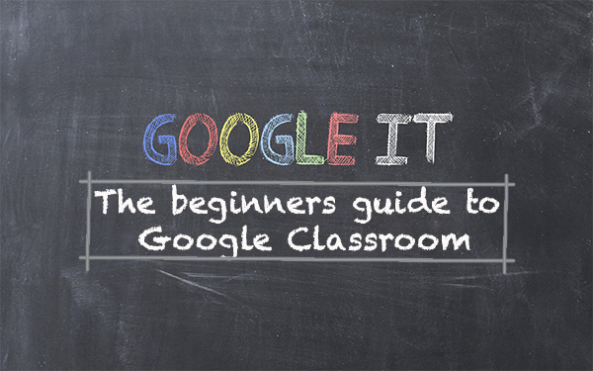

Underpinning Technology Guidance Materials

Annex 2 - How to Guide for learners (G-Suite for Education)

2020/2021 Training

Logging in

Everyone will be given an email address at the start of the training, you must change the password you are given and keep it safe.

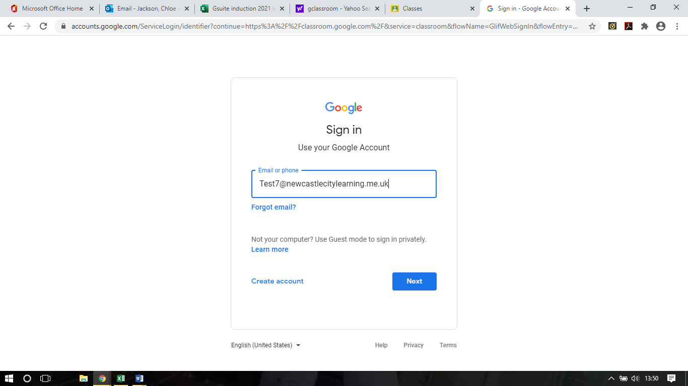

You will need to search classroom on google, you will be asked to log in using you NCL email address and password.

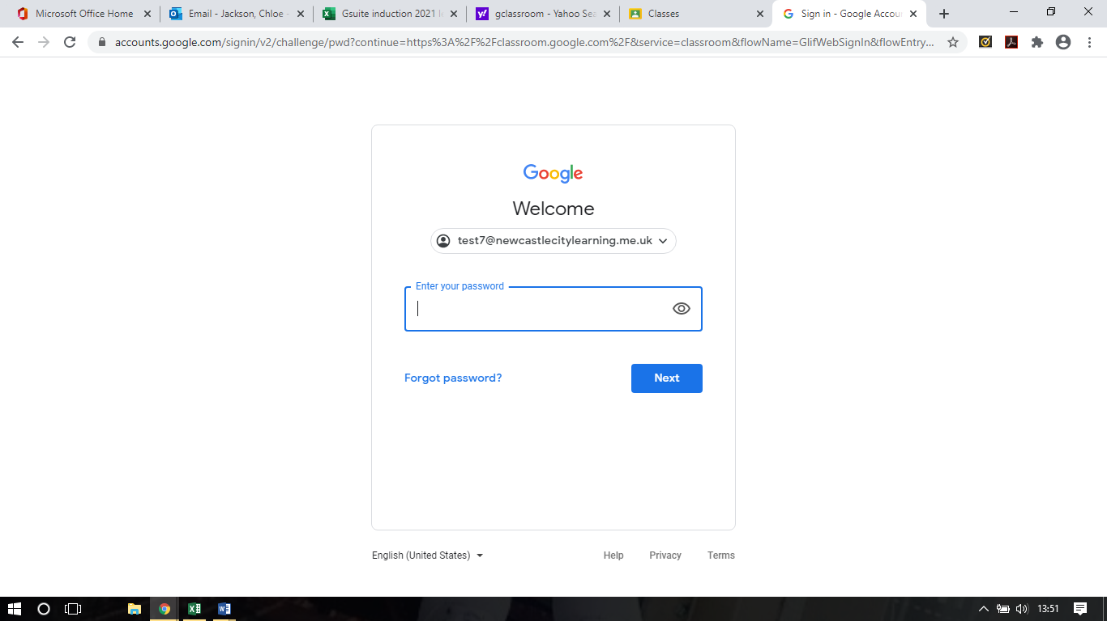
When you log in all your classes will be on your front page.
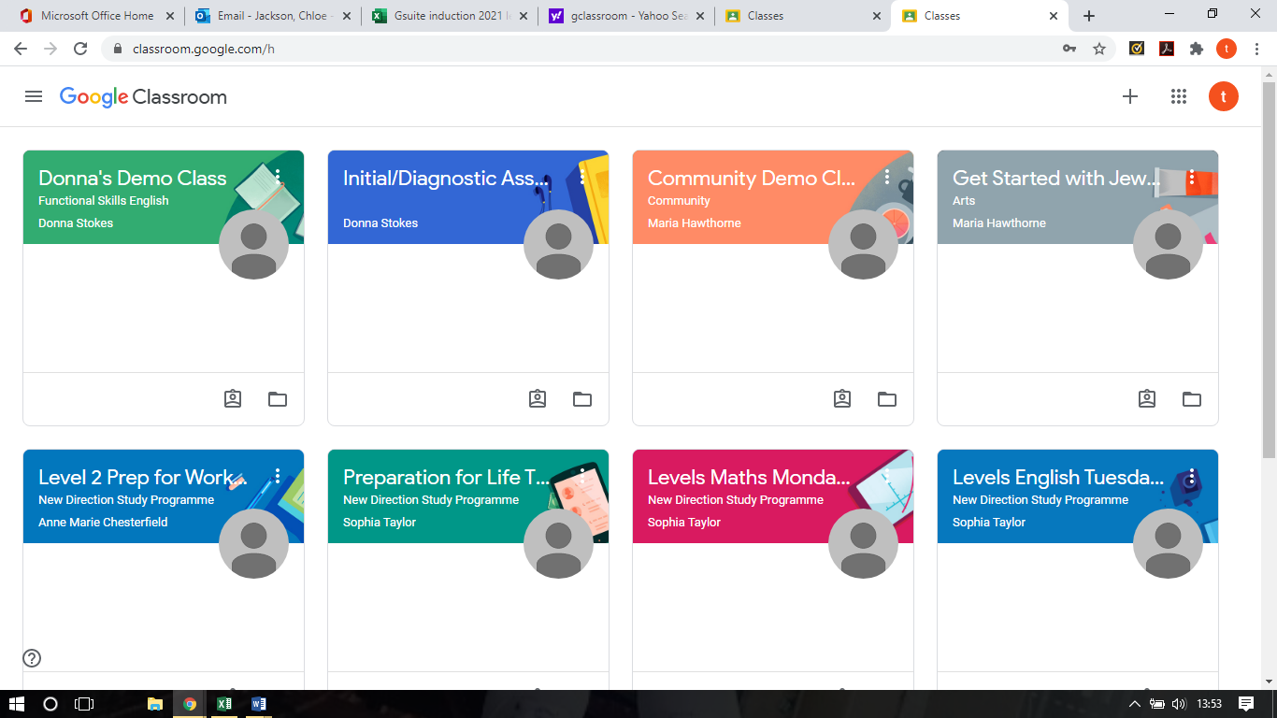

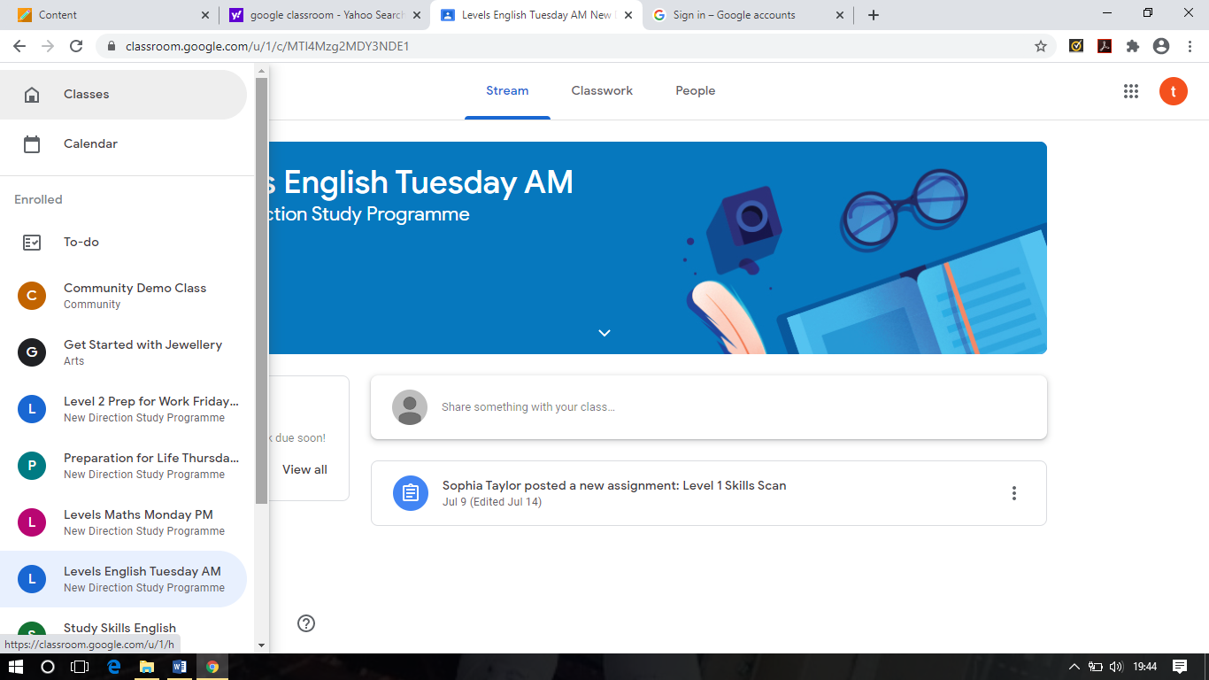
Once in the classroom you can switch classrooms using the left had side of the screen, clicking onto the three lines.

To enter the classroom, click onto the one you need to be in on that day.
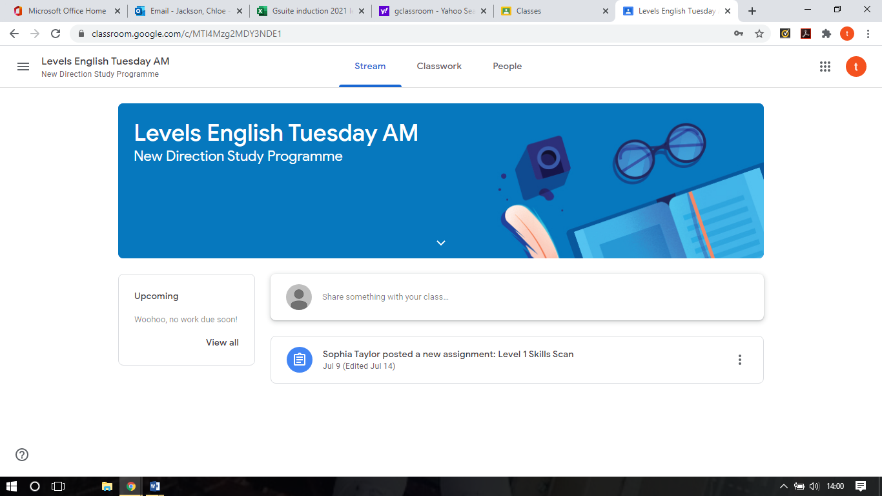
Any work you have coming up will be at the left-hand side.
All work that has been set by your tutor will be directly underneath your class details.

If you would like to write something either to the tutor or other students’, it can be done here.

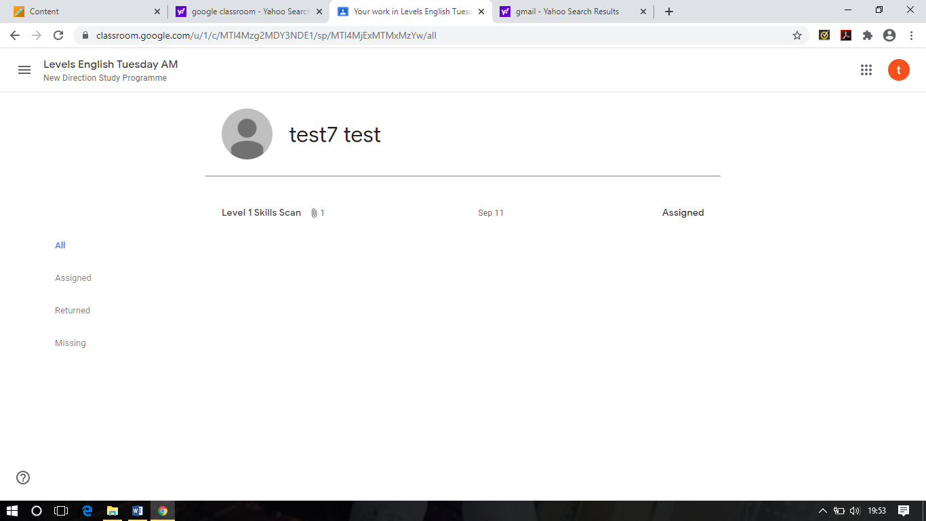
Clicking on the Upcoming page on the left hide side allows you to see what assignments you have been set, which ones you have outstanding and which you have returned.

Clicking onto classwork in the centre of the page will show you your work, due date and google calendar.
.

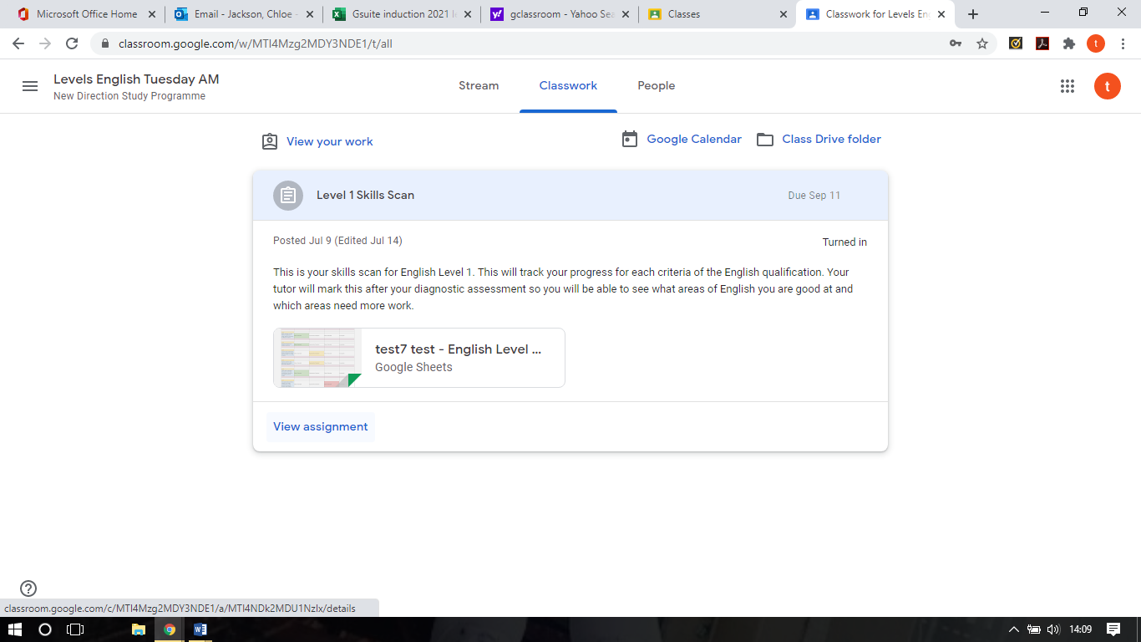
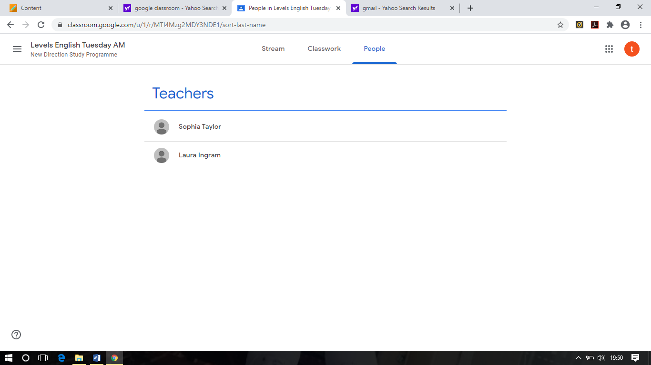
You can find the teacher for each course under people, if you have any questions on work these are who you must contact

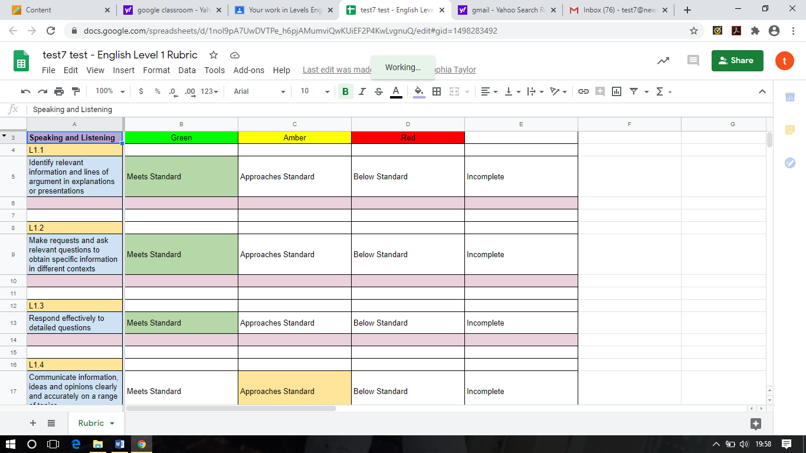
When you have been set work by a tutor you need to click on the document. Any work you complete will be automatically saved whilst you work. If you have a problem with this, you must get in touch as soon as possible.



Online Classes

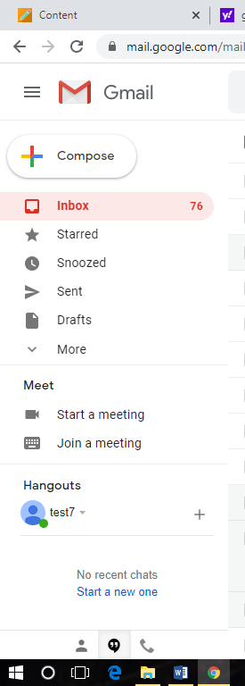
It is important you check the Gmail you are given daily, you will be sent information from you’re tutor. Including dates and times of your classes.
Each individual tutor will send information for classes, these invites will automatically go into G Classroom and you can click on them at the time you need to be available.



Cameras and microphones must be turned on for each session.

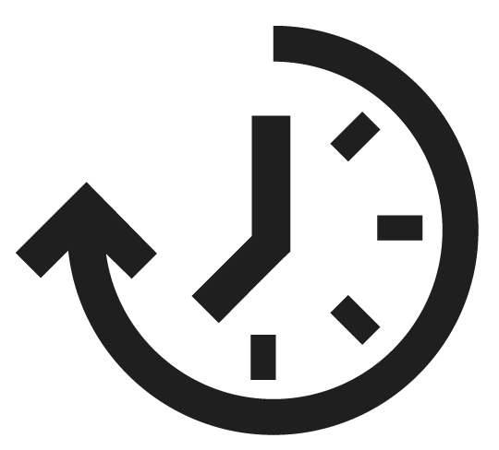

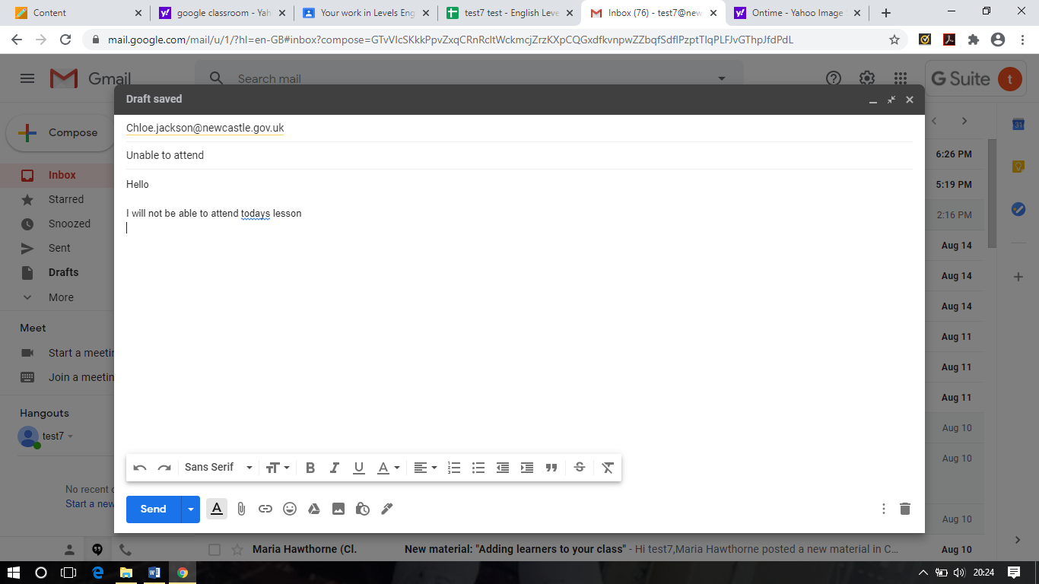
These sessions marked as usual classroom sessions so please be on time. If you are going to be late or cannot attend the session, please get in touch with the tutor as soon as possible.
To send an email to your tutor, log into Gmail and tap the compose button in the top left. You will need the tutors email address.

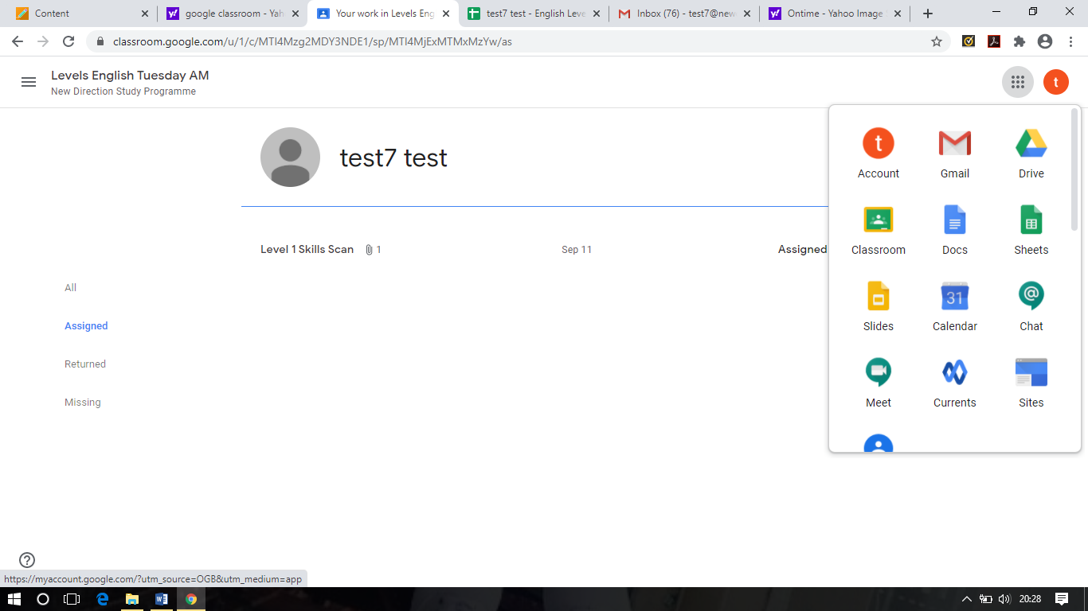
You can find Gmail as well as other information on the right side of the screen by clicking on the circle with your initial in.



If you have any questions please get in touch with your class tutor or pastoral support.

