

Underpinning Technology Guidance Materials

Annex 3

How to download a Word document from Google classroom

You may want to download the guides as word documents and/or print them or tell your learners how to do this, so here’s how:

- Choose the resource as below
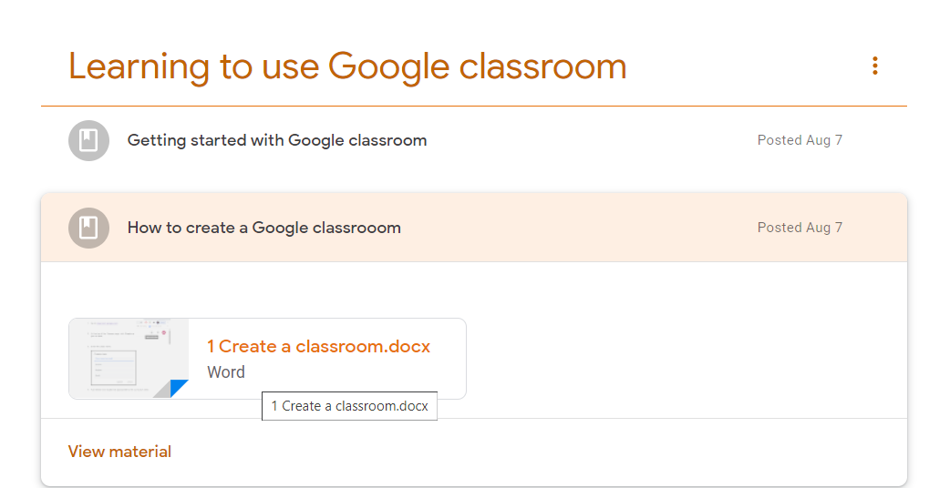

- When the document opens, choose More actions, Open in new window

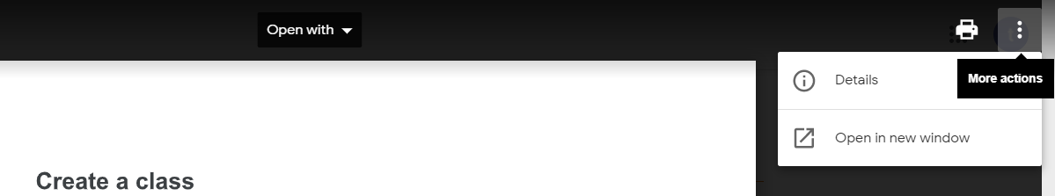

- You now have the option to Download onto your computer

