

Underpinning Technology Guidance Materials

Annex 4 - Example resources from G-Suite for Education
- Google JamBoard – Personal Study Plan
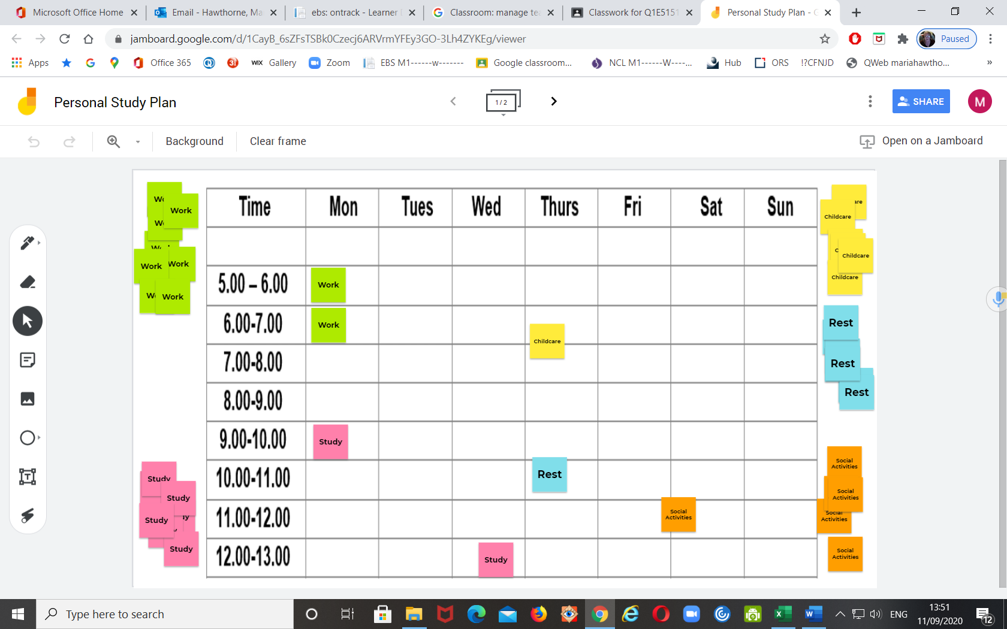
- MFL quiz in Google Form
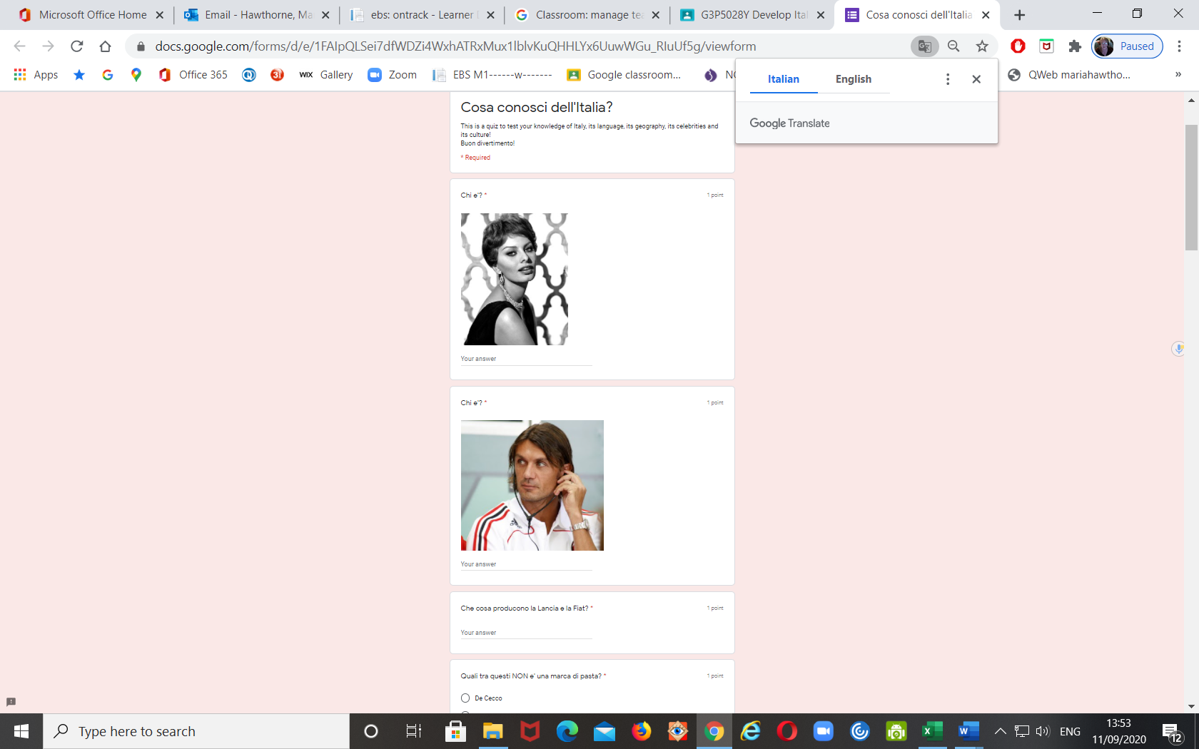
- Individual Learning Journeys (ILJs) using Google sites
Newcastle City Learning are now using Google sites for their ILJ’s.
The ILJ is shared between the learner and tutor, with the learner deciding what they want to share and when they publish. Work is uploaded to and from an online portfolio, so everything is in one place.
The series of screen prints below shows what an arts ILJ looks like now.
