Further Education Professional Development Grant – ACE Digital Leaders
Action Learning Set 1 - Effective support for learners with SEN when delivering online

Appendix 2 – Case Study – Using Microsoft Applications to support learners with dyslexia and other learning difficulties

During the first lockdown learners were thrown into online learning, many with little or no experience of this, especially learners with additional needs who tend to have even less experience of using technology in learning. This experience taught me that my learners would need to be more confident in using technology in case of future lockdowns or breaks in traditional teaching. As an organisation Essex chose Office.365/Teams to be the new teaching and learning platform. As a tutor I embraced this new development, as I felt this would be an incredibly useful tool to develop the skills of my learners. As an application it is widely used in business and as such would build vital skills especially in my Employability classes.
In the past 2 years Microsoft have rapidly expanded the assistive technology embedded in their Apps. This is of great benefit to our learners and enables them to access a wider range of technology more independently than ever before. As a Tutor I have embedded new and existing technology wherever possible in my lessons and encouraged my learners to utilise their learning outside of the classroom. There are a range of assistive functions that have been developed or expanded in the past two years which have made online learning easier, especially for those who might struggle to read.
In my classes traditionally the LSA might be used as a reader for learners who struggled with the written word. This is fine in a traditional classroom or online when staff are available, however this reduces the opportunity for learners to be independent in this aspect of their learning. Read Aloud is a function available in a range of Microsoft Apps (Office.365) and in Edge. If you are viewing a Word document (such as this), you may find that if you click on Review, you have the function available to you. However, this is not universal as many people have older versions of Word etc. that don’t support accessibility functions.
Learners that struggle to type or write but have good verbal skills might use Dictate found on the Home tab. This enables learners to speak rather than type into a document. There is some language to learn in terms of punctuation but if used regularly can make the process of ‘writing’ a more enjoyable experience for some. My learners have experimented with this when writing up their progress journals in Notebook. Although there has been mixed success the skill of speaking into your device is a transferable one which they often use to spell check using Siri or Google.
Several of my learners have traditionally used an overlay this can be substituted in Word and other Office.365 applications by changing the Page Colour in Design or if you have it by using the Immersive Reader found under the View tab. Online when using Edge, Immersive Reader can be found by clicking the book and speaker icon. I encourage all learners to try out as it can be used to adjust the reading settings in a range of ways. Not all websites have this function yet, but many do, it can be found in the webaddress bar, next to the favorites star. This option allows my learners to chose page colours, pace of audio, and areas highlighted/ focused on as the page is ‘read’. An alternate to this is the Read Aloud function which has far less options, but can be found in the Settings and more menu to the right of the webpage. I have encouraged my learners to use these functions whenever possible to familiarise themselves with the process and enable them to interact more freely in a digital society.
For images of the icons discussed see table here.

Focus on Outcomes
What did we do? | Why did we do it? | How does this support the learners?
Audit learner technology to identify what learners had access to – encourage learners to download the latest versions of software where possible | Some learners don’t have access to technology at home or the technology they have is out of date – this included software access | Learners who had no access to suitable technology were put forward to receive a laptop / Wi-Fi dongle  Learners were shown how to download relevant software to their device
Embed Teams/ Office.365 as an integral part of the courses | SEN learners have traditionally had less embedded teaching of IT – therefore most had low level digital skills | Learners are more confident in using technology and applications that they are likely to use outside of college
Encouraged learners to bring in their own technology to work on | Learners have access to a wide range of technology which work in slightly different ways  We were able to support learners to access appropriate software / apps for their devices | Technology is familiar and learners have opportunity to use it in a supported environment to learn new skills and to download relevant apps
Created a login document which was printed for the learners to take home and had images to show each step | Logging in was identified as a major stumbling block for learners/ staff  Some learners were identified as having memory issues so would continually need to follow instructions to be able to access IT | Learners/ support staff were able to follow the instructions to log onto the system  This was particularly useful when different staff / family members were supporting at home as they had printed instructions to follow
Used Office.365 apps Class Notebook, Word, PowerPoint, and Forms regularly in class with Edge as the preferred search engine | There are a range of functions within the apps that are the same across all of them  The apps are accessible across a range of devices and operating systems  Learners didn’t have to learn how to use a different system – Word and PowerPoint were already familiar to some learners  The skills learnt would be transferable  The accessibility options are widely available on the Microsoft / Edge platforms | The learners had less new information to learn  Office.365 is widely used and the skills that they took away would be transferable to future learning and employment  Encouraging the learners to use the apps across classes has made them more comfortable in using them  It stretches and challenges the learners to extend their existing skills  Learners have become more confident in using the apps for a range of purposes  Learners have been able to work more independently
Encourage learners to make full use of accessibility tools | Many of the learners’ struggle with additional needs such as dyslexia, or may have a learning disability which has resulted in them having a low reading or writing ability this discourages them from accessing IT as they fear failure | Learners can use any tool that supports their learning  Focus is moved away from what a learner can’t do and onto things that they can use to succeed  Learners get more enjoyment from learning as they can be active participants as opposed to passively getting staff to do it for them e.g. using dictation for learners with good speaking skills, but weaker written skills; using Read Aloud/ Immersive Reader to support learners with dyslexia who struggle to read documents

Table showing Key Accessibility Functions in Office 365/Edge and their Icons
Note that these images were taken in Word and Edge. However they are transferable in many Office 365 Applications including PowerPoint/Forms/ Notebook
Function | Icon
Read Aloud in Review tab (Word) | 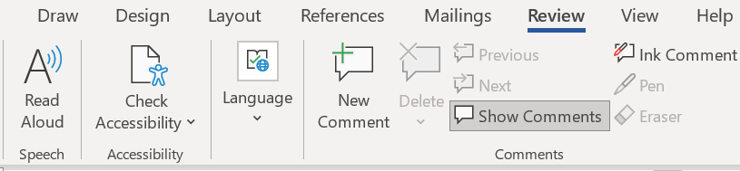
The same icon Read Aloud is used online in Edge under the Settings and more dots to the right of the address bar | 
Dictate found in the Home tab in Word | 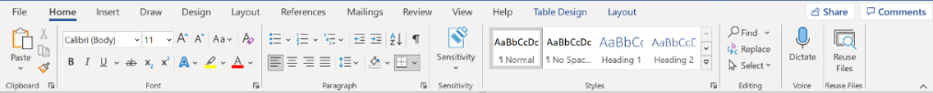
Page Colour found in the Design tab in Word | 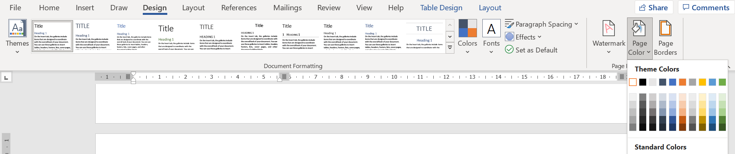
Immersive Reader - this opens a range of options including Read Aloud / Text Preferences (Font, Page Colour etc) / Grammar Tools and Reading Preferences.  In Word I type Immersive Reader into the search bar to find it. | 