HOLEX Digital Champions
A guide for Adult Community Education services looking to implement the role of Digital Champion within their own organisation



March 2022
Contents
1. Background 3
2. Why have a Digital Champion? 3
2.1. The Intent 4
2.2. Benefits to Services 4
2.3. Benefits to the person undertaking the role 4
3. Who is a HOLEX Digital Champion? 4
3.1. A summary 5
3.2. Person specification – skills and attributes 5
3.3. Job role & responsibilities 5
3.4. Building a digital culture 6
3.5. Different kinds of Digital Champion 6
4. Examples of Digital Champion Tasks 6
4.1. Assessing technology within your service 7
4.2. Approach to innovation 7
4.3. Evaluating software/hardware for teaching and learning 8
4.4. Solving problems and tackling resistance 8
4.5. Engaging staff and embedding support 9
5. Top ten tips for Digital Champions 10
6. Top Tips for tutors (online teaching) 10
7. Sharing good practice/working with others 11
7.1. Connecting with other Digital Champions 11
7.2. Connecting with other, wider parts of your organisation 11
8. Case studies: Digital Champions 12
9. CPD opportunities 15
9.1. CPD formats 15
9.2. CPD for Digital Champions 16
9.3. CPD for staff 16
10. Digital Champions’ Gap analysis – case studies 18
11. Thanks and acknowledgements 26

- Background
The providers involved in the project bid collaboratively for a share of funds from a Further Education Professional Development Grant which aimed to strengthen professional development in the FE workforce. They successfully secured funding to run the ACE Digital Leaders project, the focus of which was around Workforce capability and confidence to use technology effectively in education.
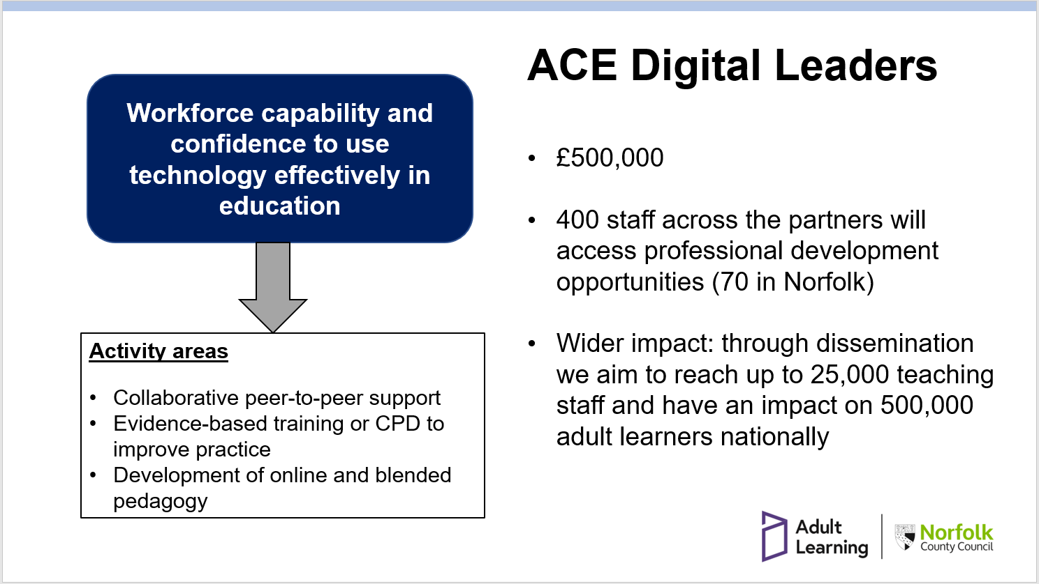
The Digital Champion arm of the project was included to:
- recognise and formalise the role that some people are already playing in their organisations; building the role into job descriptions to embed the work.
- identify and build upon current strengths.
- support those individuals who are already explicitly or implicitly doing this work.
- identify challenges associated with the role and to work collectively to address these.
- create a network of Digital Champions who can support each other and grow stronger together.

The project aimed to achieve:
- An improvement in confidence, job satisfaction and increased knowledge in the use of digital equipment in education for staff.
- Collaborative peer-to-peer support and development of online and blended pedagogy.
- Why have a Digital Champion?
Having a Digital Champion or formally recognising that someone is already doing this role has wide-reaching benefits. The purpose of a Digital Champion is multi-faceted; a Digital Champion acts as a leader in sharing digital ideas and best practice within the organisation. Having a member of staff designated as a Digital Champion enables a streamlined approach to the use of technology within the service, liaising with teaching staff and IT support and avoiding wasted time and duplication.
  - The Intent
The purpose of the HOLEX Digital Champion role is flexible and will look different depending on the organisational needs; however, it is underpinned by the intent:
“To empower staff to use digital tools more effectively in order to enhance the learning experience.”
  - Benefits to Services
The benefits to an organisation of having a Digital Champion are wide-ranging; strategic benefits including cost saving, futureproofing, planning and analysis, and staff and learner benefits include increasing confidence and developing the use of technology.
A Digital Champion helps to ensure that your service is using best practice and spending money effectively to get the results needed (whether that be with hardware, software or training purchases). They can support the introduction of new technologies by providing an ‘all angles’ viewpoint at the analysis stage. By bringing together a focus on digital technology and recognising importance of technology in a learning environment, this sharpens the focus and encourages discussion and engagement. A Digital Champion can help a service to look to the future and keep current in terms of use of technology. Through collaboration with others (internal and external), Digital Champions can support learning and maximisation of use of technology and identify new ideas and opportunities in the education technologies space.

A Digital Champion can help to keep staff skilled and included - as services move to increasing use of technology, we run the risk of isolating staff if the proper support and training is not available. Having a known contact for digital queries increases staff confidence in being able to share their digital issues (whereas otherwise they may feel concerned about sharing their limitations or challenges). Digital Champions can help with the roll out of new schemes and training and can act as a conduit to ensure that issues are identified.
  - Benefits to the person undertaking the role
A formally recognised Digital Champion can benefit from having a validated opinion and a voice within their organisation to positively influence decision-making to ensure best outcomes for learners. Digital Champions can draw on support and expertise from the Digital Champions network, including resources and experience from others who appreciate the challenges faced. Digital Champions can find that the role supports them to gain communication skills and confidence sharing new technologies.
- Who is a HOLEX Digital Champion?
ACE services vary widely in size, scope and structure. As such, the HOLEX Digital Champion role is likely to manifest itself very differently in different organisations. It should be acknowledged that this role is not a one-size-fits all, rather an organisation should take from this document what will work for them and their staff.
Regardless of the above, there should be common threads that underpin the type of person who will thrive in this role and the aims/approaches that are used.
It is likely that, when this role is first embraced within an organisation, the person assigned to the role will already be helping others in this sphere in their workplace.
  - A summary
See our video here giving an overview of who is a Digital Champion and what it means to be one. Video made with simpleshow video maker.
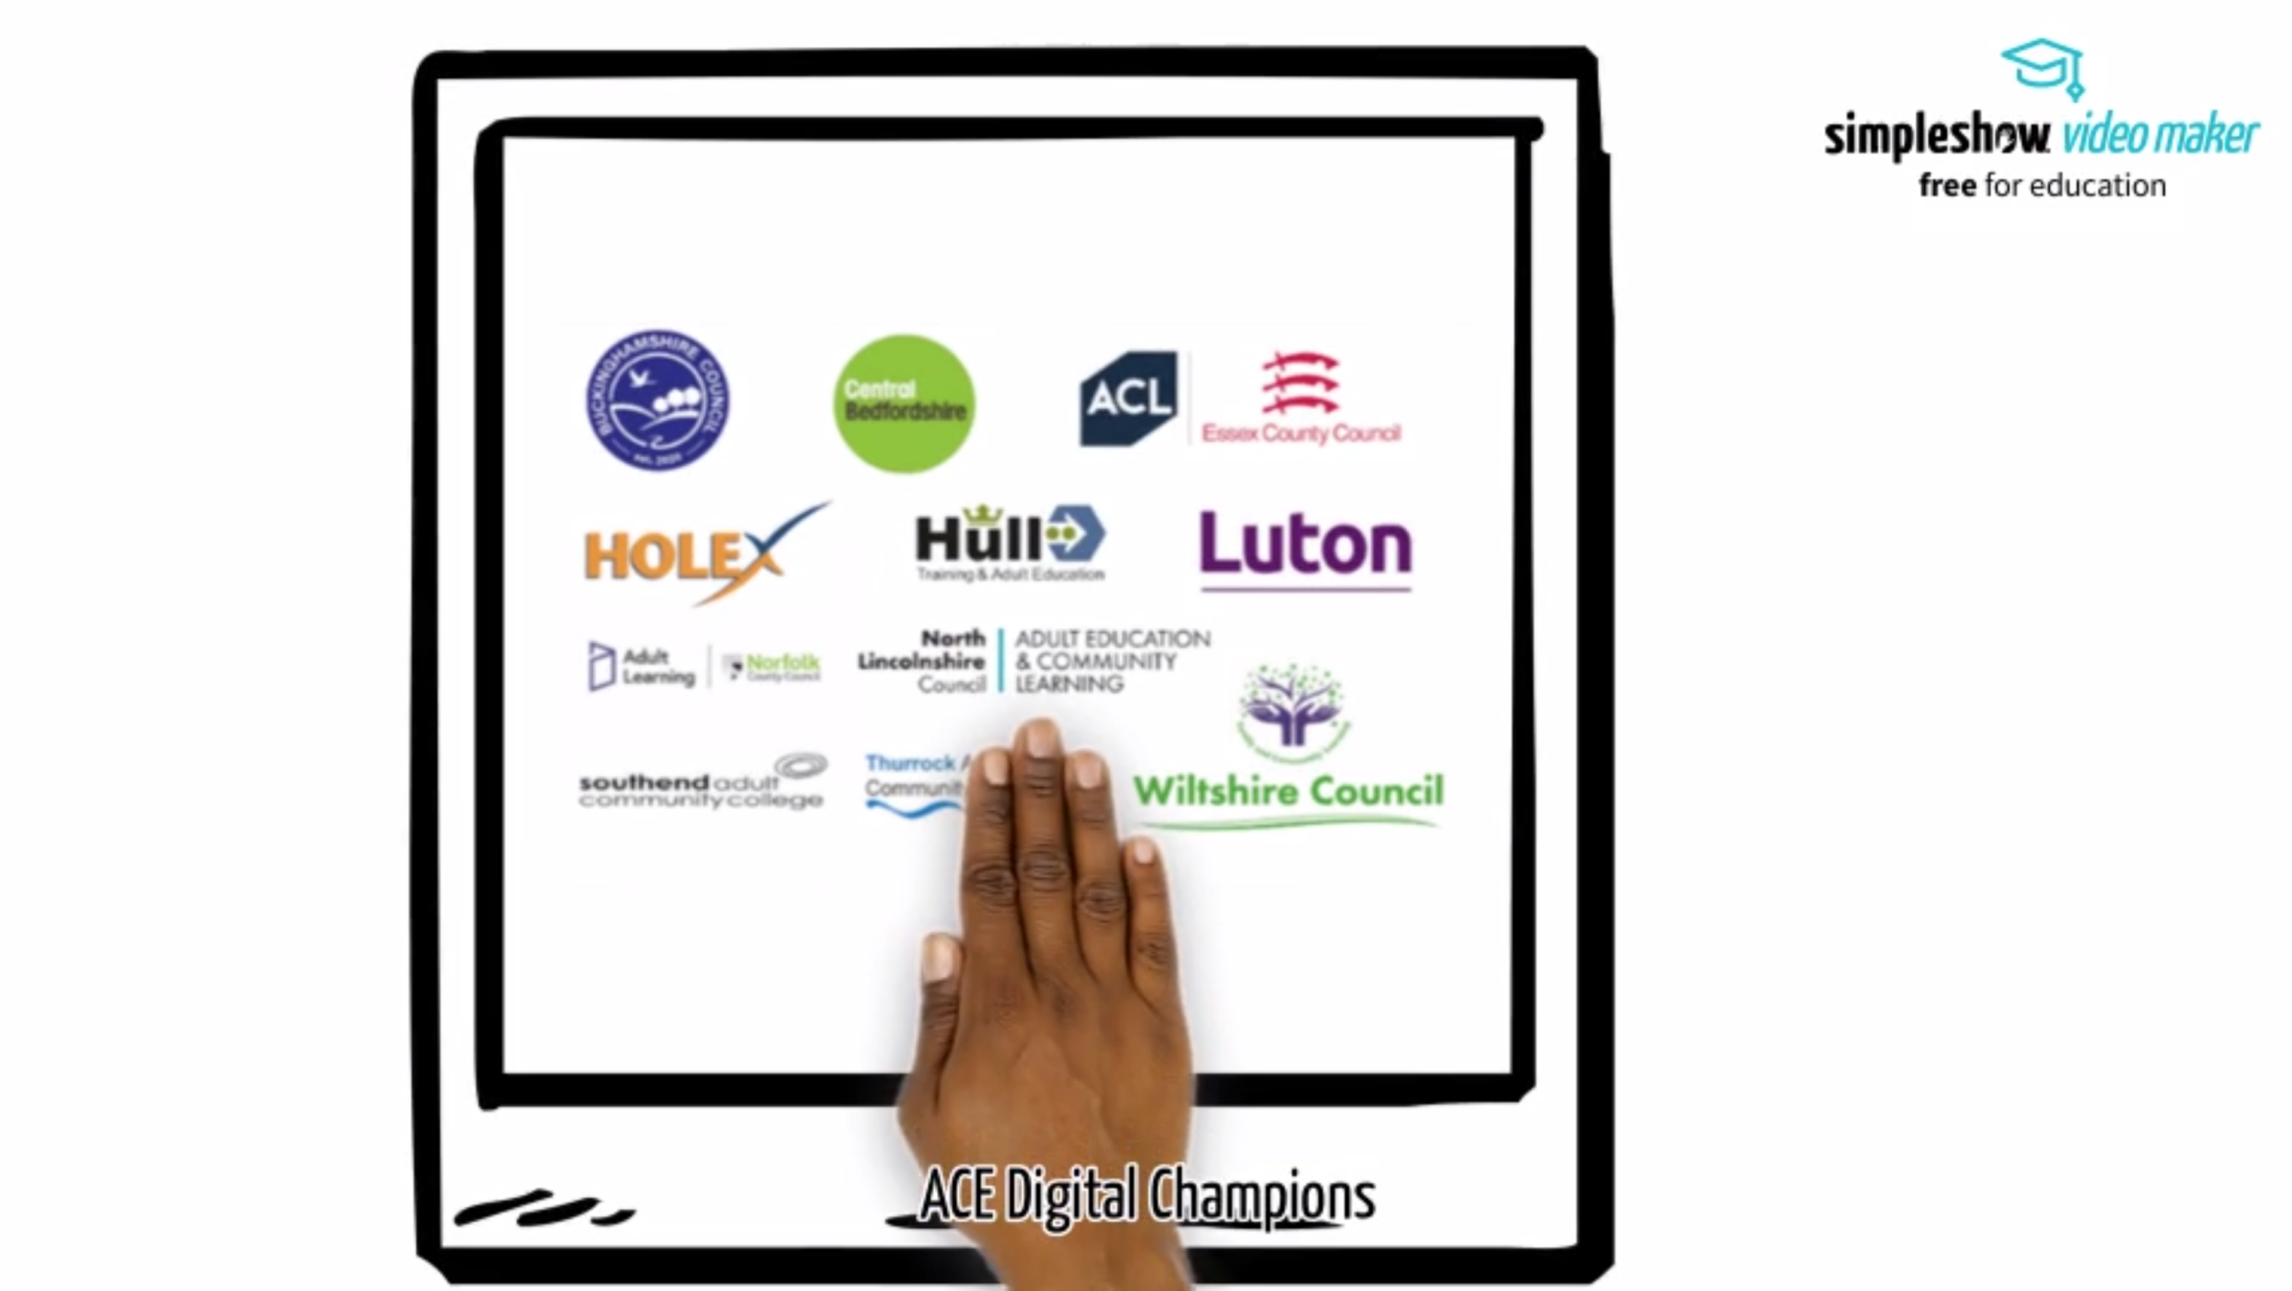
  - Person specification – skills and attributes
The person who takes on the role of Digital Champion is likely to:
- Have an understanding of/interest in the use of technology in education.
- Be comfortable helping colleagues with Edtech digital challenges and have a grasp of digital terminology.
- Enjoy networking, gathering and sharing ideas and making new contacts (both formally and/or informally) across the wider adult education community.
- Be innovative
- Be visible within the organisation as the person who is championing digital and be an enthusiastic advocate of the benefits of using technology in education and training.
- Get satisfaction from helping others
- Be willing to learn/keen to improve own skills & knowledge; they don’t need to know the answers but be able to signpost to appropriate help and support.
- Be empathetic; understanding of the challenges of using technology (and the pressures; knowing that everyone’s tech journey is at different rates).
- Be able to get to the root cause of issues by asking probing questions
- Be inquisitive; ability to explore a range of solutions to suggest tools, approaches or training.
  - Job role & responsibilities
The Digital Champion is likely to lead the way, encouraging and inspiring colleagues to maximise their use of technology in education. They play a key part in:
- raising awareness of available technology & the cost/benefit analysis of new tech
- encouraging the embedding of technology for teaching and learning
- building colleagues’ confidence in using technology and in their ability to investigate and try out solutions themselves
- encouraging colleagues (where appropriate) to cascade learning and digital confidence to peers and students
- addressing the varying digital needs of staff with empathy and understanding
- working collaboratively with colleagues to identify knowledge and technology gaps
- researching and identifying available teaching and learning tools
- guiding other practitioners in their own service and beyond, in the development of their use of technology for teaching and learning
- involvement in networking and discussion opportunities with other partner organisations.
  - Building a digital culture
Digital champions should help build a digital culture within their organisation. A digital culture is positive, collaborative & curious about technology.
To start to build a digital culture, a digital champion should:
- Enthuse (be positive)
- Empower (collaborate, share)
- Expect problems (be curious – I wonder why that didn't work?!)
  - Different kinds of Digital Champion
As noted above, the Digital Champion role will vary across different organisations in terms of both the expectations of the role and the time allocated to achieve these.
Some organisations may have a hierarchy of staff reporting to one lead Digital Champion or may have a network of Digital Champions within their organisation.
The role could cover one or more of these levels:
- Digital Expert – support staff with troubleshooting digital problems, create user guides and help videos, carry out cost/benefit analysis for new technologies
- Digital Enthusiast – develop informal opportunities for support (eg lunchtime tech talks/ clinics), encourage sharing of ideas by setting up an area for pooling resources, network with other digital champions for ideas and development opportunities
- Digital Trainer – assess staff needs in the organisation, develop CPD programme for staff regardless of their starting points, run training for staff to upskill.
- Digital Facilitator – organise technology requests, distribute resources.
- Examples of Digital Champion Tasks
The role of a Digital Champion could include some of these tasks:
- Assessing technology within your service
- Investigating models of practice
- Evaluating software/hardware
- Solving problems and tackling resistance
- Engaging staff and embedding support.
  - Assessing technology within your service
What do your staff want? What are the needs of the Service to achieve an increase in digital skills?
Factors to consider when self-assessing:
- Vision – Do you have a vision for introducing / increasing / embedding digital skills within your service?
- Technology - Do you have existing technology or are you starting from scratch? Does what you have meet the needs of your staff and learners? Is it accessible for all? Have you got corporate restrictions such as budget, GDPR, network limitations?
- Staff - Do you know what your staff needs are? Have you carried out a gap analysis? Do you know their out needs, fears, strengths, motivations? Can you identify your pocket experts? Are they being used to share knowledge?
- Resources– Is there a community / platform where good ideas, help and resources can be shared?
- Processes - Are they clearly defined? Do you have clear guidelines for staff and learners using technology? Are staff consistent in their approach? Is there a Digital Teaching Policy? Have you set digital ground rules?
- Culture - Are staff positive about technology? Do management lead by example? Is the impact of the technology being measured?
Skills surveys can be created using Microsoft or Google Forms.
Some examples:
- Tutor skills / confidence scan for Google
- Coordinator feedback survey on teaching technologies
- EdTech Tutor Skills Survey
- Digital Skills Analysis for Microsoft
  - Approach to innovation
With the change to online learning during 2020, new pedagogies were emerging. These need to be considered when using digital tools.
Design Thinking (Jisc) is one example of a systematic approach to innovation. It can assist in overcoming obstacles that inhibit progress. It is a structured way to generate and refine ideas.
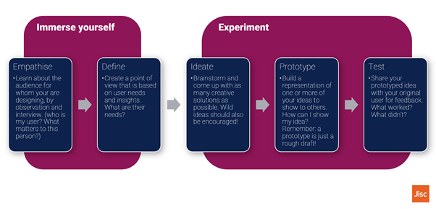Jisc also offer a Co-Design model. This encourages the engagement of all stakeholders to enable better working relationships and gain the best outcomes. ”Co-design involves working effectively with people. Therefore, a lot of effort should be dedicated to engagement in any co-design project." Co-design | Jisc
  - Evaluating software/hardware for teaching and learning
Which tools are the best fit for your organisation?
When considering the platform you will use eg: Google, Teams, Canvas, Moodle, Blackboard etc, or assessing a new process or piece of software:
- Identify the purpose for the software/ hardware – what do you want to achieve (refer back to your vision)? How does it support the pedagogy?
- Carry out a cost/benefit analysis - Is it value for money? Are costs one-off or ongoing? Is there room for expansion (eg further licences?)
- Consider compatibility – will it work smoothly with any existing tools? Does it have a similar look/feel/interface? Do staff already have the skills to engage with it?
- Analyse the breadth of the impact – will it enhance learning for a single class, subject, centre or the whole service?
Platform Analysis:
- Google Workspace
- Microsoft Teams
- ItsLearning
- Padlet
  - Solving problems and tackling resistance
How to identify barriers and then create guidance, signpost and/or troubleshoot?
Are the barriers emotional, knowledge-based or technical? Areas of concern can be categorised using the TAP format - different types of issues need different approaches to mitigate them.
Technology issues often manifest as: 'it doesn’t work’. Mitigate this kind of problem with equipment / trouble shooting. Eg: The sound doesn’t work on a video call - trouble shoot to resolve and create or locate support resources for next time
Attitude, such as resistance, anxiety, fear of failure, which may present as 'I don’t need this’. Mitigate this type of issue with direct offers of support. Eg: A tutor doesn’t want to use a new process or piece of technology – offer shadowing, demonstrations, co-teaching, etc
People’s skills and experience, which manifests as ‘I can’t do this’. Mitigate this kind of problem with training, CPD, networking and sharing of best practice with others. Eg: A member of staff wants to do a poll for an online lesson but doesn’t have the facility in their conferencing software. Put them in touch with a tutor who uses kahoot/menti/etc

  - Engaging staff and embedding support
How to engage staff? How to provide support, share experiences and develop skills and confidence?
Formal:
- Use Microsoft OneDrive, Google Drive/Classroom or a website as a resource bank for support materials (including links, printable guides and video walkthroughs)
- Schedule CPD to cover specific topics
- Signpost to, or deliver internally, accredited and non-accredited digital courses
- Provide lines of support when doing things for the first time– such as a co-teacher for an online lesson
Informal:
- Lunchtime learning – 10-minute demonstrations of software tools
- Twitter hashtags
- Microsoft Teams chat/ Google Classroom stream for tutors to ask questions, share experiences and ideas
- Top tech tips – published regularly in newsletters or via chat channels
- Tech clinics or launch sessions when new technology or processes are introduced (record sessions where possible)

- Top ten tips for Digital Champions

- Start with a skills scan – to identify the starting point. Identify your success and challenges
- Identify your key team members - who can support tutors with specific technology needs and the role out of new skills
- Include learners – by skills scanning learners you can identify skills/expertise which can be used for peer support
- Management buy in – vital to support the development and future proofing of the digital growth within the Service
- Staff network - informal channels of support complement CPD and improve confidence – tech coffee mornings, support drop ins, etc
- Clear communication – with all staff (LSAs, tutors, coordinators, management) and learners of what the needs are and how to address those needs. Explaining rationale is vital to get buy in
- Sharing of good practice – it is important to share what works well and how it benefits the learner experience; this sharing could be between departments within a service, with other departments of a local authority or with other ACE services (see more below on this).
- Be consistent - to minimise duplication and create a consistent learner experience (discourage tutors purchasing software to meet individual needs – from a quality perspective we should control the software in use)
- Allocate time – adopting technology and learning skills takes time, factor in time to create supporting documents and introductory videos before launching a new tool/idea
- Recognise that supporting learners supports tutors – create signpost resources (eg places with free WiFi / computer access), and learning resources and help documents to support learning anytime, anywhere.

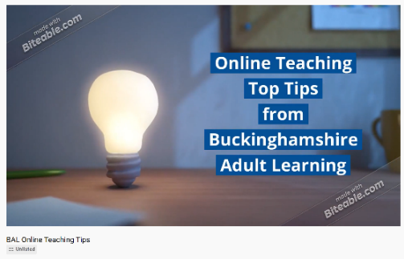
- Top Tips for tutors (online teaching)
Buckinghamshire Adult Learning made this short video giving Top Tips for tutors teaching online.
A Holex Digital ACE presentation covering the steps to moving staff to expert is available with a structured approach to identifying gaps, CPD planning and building confidence.
- Sharing good practice/working with others
  - Connecting with other Digital Champions
Working with the digital champions, we have found that sharing problems we are facing within our organisation with each other has been invaluable. More than likely someone within a different service is either facing the same problem or has already solved it. Make use of the networks you have available to you, sharing good practise with your peers will not only help with current problems you may be facing but also future issues.
If you work for a HOLEX member service, as a Digital Champion, you are entitled to join the HOLEX Digital Champion network consisting of an e-group and virtual meetings to enable you to reach out to others in similar roles across adult education providers in England. To be added to this group, please sign up here.
A couple of quotes below (following a HOLEX Digital Champion workshop) demonstrate the value of liaising with Digital Champions from other ACE services:
- It was good to hear from others, networking together to find solutions and just to know we are not alone.
- Lovely to hear from people who are dealing with the problems we have and beginning to consider solutions.
- Seeing that other services were experiencing similar issues and getting answers to some of my conundrums.
- It was refreshing that it was all Adult and Community teaching.
  - Connecting with other, wider parts of your organisation
It is probably a given that you should share good practice with your direct peers within your department.
However, if you operate as part of a wider organisation such as a local authority or FE College, consider reaching out to the person in your organisation who is responsible for the use of technology in education in other areas; for example, your local authority may have already tackled some of the challenges you are facing in schools and might have technology tips to share.
Alternatively, they might be able to learn from you; either way, these are logical relationships to consider.

- Case studies: Digital Champions
The working group for this project consisted of ten Digital Champions from a variety of ACE services. As noted above, the Digital Champion role is likely to vary both between organisations of different sizes, and also between those with different structures or different approaches.
Case studies are included below to illustrate how the role of Digital Champion takes shape in a number of different ACE providers.
Christiane Astridge
Programme Lead for Family Learning, Childcare, Supporting Teaching and Learning in Schools and Youth Hub at Luton Adult Learning.
Luton Adult Learning is a relatively small adult learning provision within a unitary authority. It has around 50 teaching staff including those on part-time and full-time term-time only and 52-week contracts and casual staff who deliver learning to around 1500 learners annually.
Although I have no formal training in the use of technology in education, I have always been keen to develop my own digital skills as a teacher and have been interested in exploring different ways to use technology in the classroom to promote active learning such as learner blogs, Prezi, collaborative learning tools and applications like Socrative and Plickers. When the pandemic hit, I realised, as a Programme Lead, that I would have to support my team of teachers to explore new ways to deliver learning online and to promote our Family Learning programme that had always been promoted through our partnerships with local schools. This led me down the route of improving our website and learning how to use social media. My proactive and positive approach to this resulted in me being selected to be our Digital Champion.
I am definitely an enthusiastic Digital Champion rather than an expert, teacher of digital skills or facilitator. I am still learning how to use Excel spreadsheets effectively but I can find a YouTube clip or someone in our service to help me. We have other experts, teachers and a facilitator in our service who I work alongside. I see my role as being positive about technology and its benefit in the learning environment, encouraging the sharing of good practice across the service and supporting others to find solutions to digital problems even if I have to find an expert to do this.
One of the ways I have done this is by carrying out a digital teaching skills audit across our teaching staff to help identify what teaching and learning technological tools teachers are using and how confident they feel about using them. This has helped me to identify gaps in training and confident members of staff who are able to support others.’

Jo Loss
Learning Technologies Manager at ACL Essex
ACL Essex is the largest provider of Adult Education in the county. There are nine fixed centres across the county. There are approximately 250 curriculum staff delivering to 5500 learners (including apprentices) per year.
As an English teacher I always had a passion for using technology within my lessons to engage and enthuse the learners. I was and am an advocate for technology for a purpose not just for technologies’ sake.
During my time as English Curriculum Lead, I worked extensively with the Education and Training Foundation as a Professional Development Lead delivering sessions nationwide on using technology in teaching English and maths.
I don’t have any formal IT qualifications although I have become a Microsoft Innovator Educator Expert through their training and regularly attend online CPD sessions with other providers to continue to enhance and develop my skills.
I am passionate about accessibility and have developed training materials to ensure staff create resources which are accessible to all and meet the legal requirements.
As part of my role, I work with the Workforce Development Lead and Teaching and Learning Mentor planning and delivering training in all areas of Digital CPD. We carried out a staff skills analysis for other teaching and non-teaching staff to ascertain the needs and confidence of the Service. We have developed a variety of different training options and encourage via our virtual tea-room staff to share their ideas and best practice. We are developing a new, robust induction programme which will support new staff to feel confident with the technology and tools available to them across the Service. We have also recently launched the L3 Award in Digital Skills: Teaching and Learning to support our staff’s development.
As a Digital Champion and in my role, I see myself as an enthusiast and trainer, but my priority is to ensure the confidence of our staff and learners is there so that the best experience can be gained from the technology we have.
I don’t claim to have all the answers but will always try to support and help. It is important to find out what someone wants to achieve with the technology and to see how it will enhance and impact the learner experience.

Sarah Bradley
Digital Skills, Maths & English Coordinator at Buckinghamshire Adult Learning.
Buckinghamshire Adult Learning is a medium sized provider with around 200 teaching staff.
I have a degree in Computer Science and Business Studies and am a Google Certified Trainer. I was head of European Client Connectivity at an investment bank, then head of Business and Enterprise in a secondary school before moving into Adult Learning. Exploring ways to use technology to drive efficiency and positive change, and training others, has been an integral part of all my roles.
As part of my role as unofficial Digital Champion, I have surveyed staff on technology needs and confidence and completed a technical analysis on the conferencing software options available. This supported a decision on software approach and identified areas of need within the teams. I delivered intensive Google training to the tutors on using Meet and Classroom to deliver online learning and we assigned a digital coach for each curriculum team as a point of contact for support. I was the technical escalation point for issues via the coaches and provided one to one technical help to tutors and learners.
We developed best practice, CPD & roadmap documents and ran regular sessions on Google tools & best practices to equip tutors with the skills and confidence to teach online. This was followed up with delivery of accredited Level 1 and Level 2 Digital Skills courses (80 tutors have gained qualifications). Building tutor confidence with technology has a direct impact on learner confidence in the classroom, both in person and online.
I set up a Google classroom for resource sharing, peer support and to direct tutors to relevant CPD opportunities. I built a tutor intranet with resources & online teaching guidance and support and a learner intranet to provide video guides and printable help. On our main website we offered 'get help to learn online’ via a Google form where learners could request an hour of 1:1 support from one of our digital coaches. We created a toolbox for ‘what does good online teaching look like’ linked to the EIF criteria and began to steadily migrate our processes to be collaborative through the Google Workspace Tools.
By building robust processes around technology for teaching and learning we have a growing digital culture, with pockets of excellence and areas for development. The focus is now on developing more informal channels of tutor and learner technical support and embedding technology into all of our classes – we run lunchtime learning for tutors, digital drop ins for learners, have a Monday Tech Tip on our Classroom Stream and our growing bank of digital coaches share their experiences and ideas to disseminate tools, expertise and troubleshooting to the wider team.
I view part of the Digital Champion expert role as keeping an eye on the direction of travel of technology in the organisation – listening to ideas and issues from learners and tutors to build a picture of whether the tech we use meets the needs of our staff and learners, is cost effective, is compatible with existing solutions, is easy to use and accessible and most importantly - positively impacts learning outcomes.
A key benefit to having a Digital Champion in an organisation is that it encourages tutors to be brave and try new things, because they know they have someone to go to share their successes and new discoveries, and get advice or signposting when things don’t go to plan. Encouraging an environment of ‘having a go’ leads to learning, innovation and improved opportunities for our learners. It models resilience and a 'lifelong learning’ attitude.

Janet Annetts
Functional Skills Curriculum Lead, Adult Learning, Central Bedfordshire Council
Central Bedfordshire Adult Learning is comprised of several providers offering learning across the Council in a number of areas. Within CBC I am responsible for a team of 4 teaching staff and 1 part time learning support. We are working with the CBC Academy providing functional skills L1 and L2 maths and English qualifications for their apprentices and offering L1 and L2 to the general public where there is a need. We are growing and plan to offer some bespoke short courses to help adults support their children with English and maths and also look at IT support.
I started life working in research, in particular agricultural research and have always used the internet and the latest technology to support whatever I am working on. I came to teaching 10 years ago and decided teaching adults or over 16s was my preferred learners. I am always looking for ways to improve efficiency in my teaching and see technology potentially as a help in this regard, especially now we are all getting used to working online. Covid has accelerated the use of online technology and online teaching in a way that I don’t think any of us expected.
My role at CBC is new to me having only been here 6 months. In that time, I have gone from tutor to curriculum lead and was volunteered for Digital Champion, because I have fresh eyes and am enthusiastic about using technology. I don’t shy away from trying something new, but I would not say I am an expert in any way, shape or form.
The role of Digital Champion has enabled me to get to know my colleagues better and understand that their technology knowhow is limited to what they can manage, but also, they know stuff I don’t know. I think often people find a pragmatic solution to a problem at the time rather than thinking of a bigger picture solution. In terms of hardware, all our tutor/assessors have been offered additional screens, graphics pens etc, but some have declined suggesting they don’t need it. We forget that working in isolation and not seeing what others do sometimes leaves us behind. Demonstration by example is important, as well as allowing time for tutors/assessors to learn and recognise the importance of how digital tech can enable efficiencies.
I see my role going forward as a champion for all things digital, and hopefully by sharing our new tech and some of the ideas we can move forward in this area. I am enabled by peer-to-peer discussions with other digital champions and can see what we could do.
- CPD opportunities
  - CPD formats
CPD sessions should be offered across your organisation in various formats such as live sessions, mentoring opportunities, videos and help guides. Don’t assume that staff all have the same learning style; this will vary just as it does with students in a class. Each of the learning styles has their own benefits, as listed below:
- Live session – with a live session you have the ability to demonstrate technology with a more hands on approach. This will enable staff to practise using hardware and software in an environment where they can be guided and ask questions with a facilitator.
- Videos – Videos are great to use as a training tool as they can be accessed multiple times at the leisure of the staff member.
- Help guides – creating visual step by step guides similar to a set of instructions are very popular to use, like videos they can be accessed multiple times and can be edited and adapted quite quickly and easily if a set of hardware of software's functionality changes slightly.
  - CPD for Digital Champions
There are myriad CPD opportunities available. Below are just a handful of the key resources that the project team have accessed and would recommend.

- Enhance platform bitesize modules with resources supporting teachers across all areas of digital learning.
- ETF webinars free webinars on different areas to support digital teaching
- HOLEX Digital ACE – resources produced as part of a Ufi funded project in 2020 to assist ACE providers in getting online during the pandemic.
- ACE Digital Leaders – resources produced as part of the DfE funded project in 2021/22 – recordings of workshops/guidance documents and more – coming soon on www.holex.org.uk
- OCN Level 3 award in Digital Skills Teaching and Learning This qualification supports staff to identify their own digital gaps and develop an action plan to develop skills and resources to support learners in the classroom. Staff are given an opportunity to create and try out resources reflecting on their successes. The three units are: Digital Skills Professional Competence, Supporting Learners’ Digital Skills Development, Using Digital Skills and Resources to Enhance Teaching
  - CPD for staff
Asking staff to complete a skills scan (see resources section below for examples of these) for their digital abilities will enable you to create bespoke training sessions based on the level of competence of the staff members.
Whilst creating bespoke training sessions you will also need to consider the subject area in which the digital skills are required, the training will need to be contextualised. For example, if you were training a pottery teacher how to use a visualiser you would provide a live demo using the kit to display how your hands must be placed when using a pottery wheel. Giving staff examples of how they can use the hardware and software you have in your organisation will encourage them to utilise it.
As with CPD for Digital Champions, there are very many opportunities and helpful tools available for staff. This section provides a very small snapshot of some of the resources that the project team have accessed, along with some ideas/approaches to consider.
- HOLEX Digital ACE – resources produced as part of a Ufi funded project in 2020 to assist ACE providers in getting online during the pandemic.
- ACE Digital Leaders – resources produced as part of the DfE funded project in 2021/22 – recordings of workshops/guidance documents and more – coming soon on www.holex.org.uk
- Smart board (interactive board tutorial) – Teaching staff how to turn on the board, how to draw on the board, how to turn on the sound, how to annotate PDF, PowerPoint and various other documents. How to use SMART notebook and tools provided (games and interactivity).
- Hybrid learning training – Zoom, Microsoft Teams, using classroom camera, mic, setting up, sharing screens, collaborative working, online teaching, sharing videos, peer evaluations, GDPR for online teaching (Life drawing class for example)
- Maths – Edmodo, interactive websites available how to teach but save time, triptico to create games, liveworksheets.com, corbettmaths.com, resourceaholic.com
- Visualisers how to use effectively for teaching online – Can be used for English, Maths, Art,
- How do you create and structure an interesting, interactive and engaging lesson online? Concrete, pictorial abstract
- How to differentiate online?
- Working collaboratively online
- Making resources accessible for all
- Creating ‘How to’ guides – visual guides with embedded videos of screen recordings, screen shots, create something accessible for all staff.
- FutureLearn Courses about Online Teaching
- Open University Take your Teaching Online
- Google Teacher Centre Training & Resources
- Microsoft Classroom Tech Microsoft Education Resources
- ETF Enhance platform bitesize modules with resources supporting teachers across all areas of digital learning.

- Digital Champions’ Gap analysis – case studies
Each of the Digital Champions involved in the ACE Digital Leaders project was allocated a budget to enable them to identify gaps, research solutions and procure digital equipment that would help their teams.
The case studies below demonstrate how this was approached in different organisations.
ACL Essex
ACL Essex has approximately 250 curriculum staff (including LSAs) delivering to over 5500 learners (including apprentices) across 9 static sites and outreach buildings.
Gap Analysis
Sent a survey (MS form) to all Curriculum Leads and Managers to ascertain their views on the technology in the centres and where they felt the gaps were.
Identified Gaps
75% of those surveyed responded that there is a need for technology for hybrid delivery. Whilst the Service has already invested in devices which are suitable if one or two learners are online, it was not robust enough for larger numbers. This was deemed as valuable to support the curriculum offer where learners in a remote area could attend a class, they may not otherwise be able to and also to improve attendance in sessions.
The Approach
Through discussions with other Digital Champions, investigating the technology Essex County Council have used for their hybrid meeting rooms and speaking to other providers who offer this model we researched the most suitable technology.
The Equipment and Implementation
ACL Essex will be spending money on LogiTech RallyPlus Conferencing Hardware and a screen to display this on the classroom. We will be placing this in two rooms in different centres across the county. These have been identified through the curriculum planning process and in line with Service needs. A training plan and videos will then be put in place to develop the confidence of the staff who will be using it.
Impact
Enable all residents of Essex the opportunity to develop their skills and qualifications.
Create tutor led learning even if the tutor was not in the same geographical area.
These rooms can be used by learners and staff to connect wherever in the county you are this can be at home or in a centre.
Learners will also develop communication skills and remote working skills to assist them in future career opportunities and in the ever-increasing digital world.

Buckinghamshire Adult Learning
Buckinghamshire Adult Learning (BAL) has approximately 200 curriculum staff (including LSAs) delivering to over 2000 learners across 3 main centres plus additional satellite and community sites.
Gap Analysis
A survey (Google form) was sent to all curriculum coordinators to ascertain their views on the technology in the centres, how confident their tutors felt about teaching technology and how embedded tech use was within their team. Following this analysis, a survey (Google form) was then sent to tutors asking for specific examples of need and identifying specific barriers seen in their classrooms.
Identified Gaps
90% of the coordinators were using some form of online delivery, with 80% using technology in centres. However, only 40% felt it was embedded and 80% identified equipment availability for learners as a key barrier. The focus of the analysis was then to identify technology which would elevate the online teaching offering and integrate technology into classrooms to support hybrid delivery and integrate technology use more widely into teaching and learning, across the full spectrum of tutor digital confidence and curriculum area.
The Approach
Through discussions with other Digital Champions, attending Digital Ace webinars, exploring the technology in place through peer to peer exchange we researched the most suitable technology to meet the identified needs.
The Equipment and Implementation
BAL will be spending money to support curriculum teams to take the next step in their use to tech to better support learners. This will be via graphics pads, visualisers, conference cameras, vertical mice, Chromebooks, wireless printer, headphones and ring lights. Allocation will be via coordinators based on the needs identified in the gap analysis and in line with BAL’s strategic digital plan.
Impact
Ensure continuity of learning for tutors and learnings through development of hybrid teaching approaches – delivering through multiple channels supports good attendance which supports good achievement.
Embed the use of technology into learning, taking accessibility into account, so that all learners can develop wider digital skills which are essential for work and life.
Enhance the delivery of creative and mathematical subjects through technology to support synchronous and asynchronous learning.
Be able to deliver digital skills learning in community locations to reach those who are digitally excluded.

Wiltshire Council – Family and Community Learning
The Wiltshire Council Family and Community Learning Team has 12 staff including 6 tutors, and aims to delivery to 500 disadvantaged adult learners every year. Since the pandemic, delivery moved online, and currently 80% of courses are delivered online, and 20% of courses are delivered face-to-face in community venues with learners who have significant barriers to online learning.
Gap Analysis
Small group and 1:1 discussion with tutor team, business development manager and senior leaders, plus discussion with learners.
Identified Gaps
Three areas of need were identified:
- Some potential learners lack the technology hardware to learn online. Reliable short term loan devices would enable our service to reach more disadvantaged learners. We currently have some very old kindles being used for this which are not fit for purpose. Learners will need to be able to access our VLE itslearning (and can use MS O365 via the VLE).
- ESOL and SEND learners (with dyslexia or reading processing difficulties) may benefit from text-to-voice and voice-to-text/voice recording devices.
- Council-owned sheltered accommodation does not have WiFi but have groups of potential learners who would need face-to-face, bring your own device IT classes to help them to access essential services online.
The Approach
Potential solutions to these gaps were explored through discussion with other Digital Champions, discussion with IT staff from education settings, discussion with an EdTech demonstrator, independent research and exploring reviews of different devices online, plus a practical demonstration of some technology. Our main criteria was to look for technological solutions which offered longevity, ease of use to set up and maintain (as we won’t have support for these devices from the council IT team), functionality, security and futureproofing.
The Equipment and Implementation
Wiltshire Council Family and Community Learning will purchase 4 (possibly 5 as the price has just dropped) Acer CP311-3H Chromebooks to use as loan devices. We will be able to set up ‘parent’ and ‘child’ accounts to allow safe use of the devices during loan, as well as an easy hand-back procedure to wipe data for the next learner loan. Chromebooks are light-weight, reliable, easy to use and have over 6 years of guaranteed updates.
I explored the options for reader pens to support ESOL and SEND learners; however, learners would not be able to purchase these devices for home use. Therefore, it would be more effective and useful to support the learners (and their tutors) to develop skills and confidence using assistive reader technology on a laptop, or dictation options on mobile devices, to support their English and literacy skills development.
Through research with tutors from other organisations who have used MiFi devices in community settings, I discovered that whilst MiFi devices can be extremely unreliable. MiFi devices could potentially provide internet access for up to 20 devices, but this would be highly dependent on the mobile signal at the venue. Therefore, we have are exploring options to use community venues such as libraries for the sheltered accommodation groups to attend, where they can access reliable WiFi already in place (as well as other services offered by the library too).
Impact
These purchases and decisions would help to address digital exclusion.
Each Chromebook would be available for 6 loans per year, so 5 devices would enable us to reach an additional 30 learners per year who would not otherwise be able to access learning online.
Learners will develop their confidence using technology either online or in the face-to-face classroom. As well as developing their IT skills, they will also develop communication skills too.

Luton Adult Learning
Luton Adult Learning is a relatively small adult learning provision within a unitary authority. It has around 50 teaching staff including those on part-time and full-time term-time only and 52-week contracts, and casual staff who deliver learning to around 1500 learners annually in one main site and some community venues.
Gap Analysis
Programme leads and senior management were already aware of some gaps and we discussed them in detail in a management meeting.
Identified Gaps
Our dyslexia assessor had already identified a need for us to provide better support for dyslexic learners and had recently recommended a specific digital reader pen to us. Some of the teachers’ laptops did not produce very good quality recordings of speaking and listening assessments particularly in a group recording so we were looking for ways to improve this. Wifi access and connectivity in community settings is often unreliable so we were considering how to address this. In our management meeting we experienced issues with a number of people accessing an online meeting in the same room and other joining remotely and recognised the need look for tools make hybrid meetings and lessons more effective.
The Approach
I found that the best way to address these gaps was through personal recommendations from other Digital Champions. It was invaluable being part of this group to be able to make appropriate purchasing decisions that fitted within our budget.
The Equipment and Implementation
Luton Adult Learning will be spending money on Digital Reader pens, Jabra Conference Speakers, Hue HD Pro USB Document Cameras and Wacom One Graphics Pads. The graphics pad was something that was not initially identified as a gap because we were not particularly aware of their existence or what they could do. But through ‘show and tell’ activities with other Digital Champions we felt that these would add to the other equipment we were purchasing to improve the teaching and learning experience.
The hardware will be available for teaching staff to book out when they need it to enhance the learner experience or to improve the quality of hybrid classrooms or meetings or speaking and listening assessments. A training session is planned for staff to learn how to use this equipment and to see how it can enhance the learning experience. How to videos will also be in place for staff to access when they are using the equipment.
Impact
The conference speakers and document cameras will enable staff and learners at Luton Adult Learning to have the opportunity to access face to face meetings and lessons remotely with a better-quality sound and vision experience. It will also allow a learner to join the class, or a teacher to join a meeting, if they are unable to attend in person due to for example, a positive Covid test but are well enough to join remotely. This equipment will also improve the sound quality of speaking and listening assessments. The Digital reader pens will help to provide better learning support for dyslexic learners when recommended by a qualified assessor and the graphics pads will add to the teaching and learning experience both in a face to face and online classroom.

Bedfordshire Employment and Skills Service, Central Bedfordshire Council
I am part of the team that delivers skills for work and life within our adult learning, and we are a small part of something bigger which encumbers other providers. We also have an academy which offers apprenticeships across Bedfordshire. In identifying where additional hardware could support our teaching and assessment I looked at the inhouse delivery including the work for skills and life team and the assessors at the academy. The former is a team of 4 tutors and one learning support assistant with business administration and manager and the latter is a team of 9 assessors or trainee assessors.
Currently much of our provision is still online (Teams meetings) or as flexible learning with regular communications with tutors and assessors. We do plan to move back into the classroom environment, although the Council is encouraging home and flexible working options.
Gap Analysis
I started by sending out a questionnaire to all staff involved across our inhouse teams and external providers. This proved unhelpful as the answers were so varied and it became apparent that people do not know what they need but survive with what they have.
So, I discussed options with the delivery manager to help focus a direction that could prove useful across the in-house provision.
Identified Gaps
Hardware such as a second screen, mouse, etc have been offered previously and some have it and some don’t. It is offered as a matter of best working practise under DFE assessment across the organisation. Some staff are unaware of the benefits of these bits of kit, and in fact education is the best way to encourage its use.
We identified that as we move back into the classroom for teaching and assessment, that some learners will still like the option to learn from home. Therefore, the gap is being able to deliver within the classroom and sharing online at the same time.
Also for assessments where video/audio need capturing, how could this be done in the classroom as well as online and be captured as transcripts.
The Approach
Having established that what we wanted was a blended learning option, it was interesting seeing what other Digital Champions have set up and discussing how different hardware and software solutions to enables different things. It is all very well having hardware and software, but how you use it to effect improved teaching and learning was invaluable.
Researching affordable options and thinking about the best use of the funding enabled me to find a cheap alternative that can support as many staff as possible as we trial working in a more blended environment.
The Equipment and Implementation
We have created a “Portable Blended Learning Space” comprised of a portable projector, conference speaker and visualiser all wrapped in a carry bag which will fit a tutor/assessor’s laptop. All items are plug and play and will enable links to Teams so that those in the classroom or online can see and hear the session.
By having their own kit, staff can practise how they use their camera, speaker and projector, knowing it will all work together. A classroom camera would have been nice but too expensive, but the visualiser can capture shared learner work for all or record a discussion.
Impact
Improve the learning experience for learners and enable them to attend even when they cannot get to the classroom.
Enable tutors and assessors to use technology more effectively as they have their own kit to practise with.
Improve the capture of assessment activities using video and audio. Hopefully software solutions can help translate this to a paper-based version in time.
It will be the first steppingstone to show how good the blended learning can be. Linked with independent learning, it should create the flexible approach for all learners.

North Lincolnshire Adult Education & Community Learning
We have 40 staff including support staff and over 800 learners delivering in one main centre and a range of community venues and hubs across North Lincolnshire.
Gap Analysis
I engaged staff by creating an MS Form with a series of questions to allow staff to name equipment that they would like to have and identify something they would like to see a digital solution for. After the initial form I was then able to meet staff and talk about more specifics.
Identified Gaps
I found that the overall problem was lack of equipment to create a more seamless approach to online learning. Although all tutors are equipped with laptops and thrive using Google Classroom with their learners, things broke down with the awkwardness of just having one camera built in. This limits the ability for tutors to show learners anything other than themselves and their shared computer screen. One of our maths & IT tutors said they had seen something called a visualiser and would like to use it for demonstrating as it would display on the smartboard. However, they had no idea which one to get. I did some research and found this is also known as a document camera and could also be used with MS teams and Google meet. Another main problem was the only option of a built-in microphone in the laptop. These things made it impossible to deliver hybrid learning.
The Approach
I used my new network of Digital champions to enquire and attend peer to peer sessions and online demonstrations of equipment. I also attend the hybrid learning workshop. After this I felt more equipped to search for our own equipment armed with the knowledge gained from someone who was already doing a similar thing. After my research I manged to find a camera that could be used as a web conference camera and display documents up to A1 size. Plus, a professional web conference camera that comes with a professional speaker phone all linked through just one USB connection. My advice would be when you have used your network to ask a fellow Digital Champions about a piece of equipment they have. Don’t just go buy the same. Always check to see if there is an upgrade out there.
The Equipment and Implementation
We bought:
Mobile web conference / document cameras
One professional web camera with auto focus, facial recognition, auto tracking and a professional speaker phone.
Speaker phones
Graphics pads
Exam Reader pens
Impact
Having a network of Digital Champions is a great way of sharing information, knowledge and experiences of tech. Having a bank of resources will help our tutors with tips and ticks when using digital devices and technology. The equipment will enable us to deliver hybrid learning not only in one specific classroom, but any time any place anywhere. Having the exam reader pens will also help our ESOL learners as well as leaners who need support from a L.S.A. Giving more independence to the learners.

Hull Training & Adult Education (HTAE)
HTAE has approximately 75 curriculum staff delivering to over 5500 learners (including apprentices) across the Hull & Humber region.
Gap Analysis
Sent a survey (MS form) to departments to gain their view on technology used to support education and training, and also to identify any gaps.
Identified Gaps
Gaps identified, included the following:
Cameras to record learner work- predominately, construction & engineering.
Recording of professional discussions as part of assessment to be GDPR compliant
Vlog cameras to record sessions and post on VLE channel
The Approach
Through discussions with other Digital Champions, investigating possible technological solutions with HTAE IT staff, and feedback from the HOLEX ICT staff. We have been able to look at ideas that could meet our requirements.
The Equipment and Implementation
HTAE will be spending money on digital cameras, Vlog cameras and visualisers to support learning within the organisation. construction and engineering in particular are keen to make use of this equipment. It is hoped that staff will then support other staff in the use of this equipment.
Impact
Provide ICT equipment to support teaching
Allow the use of ICT equipment to support learning
Provide a platform to develop staff skills & confidence in the use of ICT equipment
Support learners develop their skills in ICT.

- Thanks and acknowledgements

Name | Job Role | Service
Sarah Bradley | Maths, English & Digital Skills Coordinator | Buckinghamshire Council
Janet Annetts | Functional Skills Curriculum Lead | Central Bedfordshire Council
Jo Loss | Learning Technologies Manager | Essex County Council
Anthony Vidal | Higher Education (HE) Lead | Hull City Council
Christiane Astridge | Programme Lead for Family Learning, Childcare and Supporting Teaching and Learning in Schools | Luton Borough Council
Barry Rainbird | Accredited Tutor | Norfolk County Council
Brian Altoft | Digital Engagement Officer | North Lincolnshire Adult Education & Community Learning
Jade Sampson | Digital Learning and Development Coordinator | Southend Adult Community College
Simon Burwood | Programme Manager Apprentices and Careers | Thurrock Council
Laura Trowbridge | Family and Community Learning Tutor | Wiltshire Council
Charlie McKenna | Operations Officer | HOLEX

