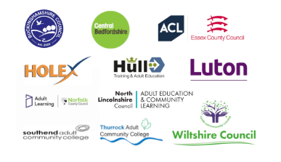

Further Education Project Development Grant – ACE Digital Leaders

Staff Network 1 - Community Learning – Best Practice in delivering RARPA online

Appendix 1 – Staff Network ideas around best practice and pros/cons of using digital tools to deliver RARPA online

A short survey was taken to collect ideas from those participating within the staff network. The survey considered best practice and the pros and cons of using digital tools to deliver RARPA online. The original survey is available here. The results are included below.

Q. What digital tools do you use for RARPA?
1. Setting aims appropriate to an individual or group of learners and local needs.
2. Assessing learners' starting points – establishing and recording the learner’s starting point in relation to the course aims / initial assessment.
3. Identification of appropriately challenging learning objectives (initial, re-negotiated, revised) and incorporating generic and individual objectives.
4. Providing formative feedback and recognition of progress during programme.
5. Capturing end-of-programme learner self-assessment, tutor assessment, review of overall progress and achievement.
6. Supporting learners to make informed choices about their next steps into further learning and work.

Responses were in free text format and are included below:

ID | Responses
1 | My short courses have not run this academic year due to insufficient enrolments so my answers are based on expectation rather than actual experience. Setting aims Assessing starting points End of course assessment, both learner and tutor.
2 | 1. ILP on Padlet 2. homework at first lesson which is then uploaded to the ILP on padlet. The homework may be on a Word document. 3. The rest I do on padlet after discussion with the student. Students also use the VLE to find out about further learning opportunities.
3 | VLE - itslearning Learners sending in photos, videos etc Interactive quizzes and surveys in VLE Menti
4 | Digital ILPs, initial diagnostic forms, review of progress through work posted to the digital classroom, digital teaching aids in online meetings (whiteboards, videos, interactive sticky notes, PP slides), 'next steps' web links, and end-of-course coursework that students receive feedback on, as they do on their ILPs. Students also have access to an optional online 'learner diary' they can add reflections to after each session.
5 | Assessing learners' starting points – establishing and recording the learner’s starting point in relation to the course aims / initial assessment.
6 | Setting personal learning goals, completing initial assessments, standardised learning objectives, providing feedback on work completed, ILPs and other evidence collected in the session. Recording of assessments on RARPAP, providing IAG to guide them into further learning and next steps.
7 | 1. Not currently digital.  2. Not currently digital.  3. At present I set (and retain completed) tests and quizzes. These are sent out via Google Classroom and the results are retained in Google Classroom.  4. My students get a homework document from each lesson unit (some lessons are half units/face-to-face [F-t-F units). I have 35 different lessons available (some are one hour, some are two hour, some come in both formats depending on how deep students want to go). Photography students all complete lesson one (2hr) and two (2hr) - the basics. After that I offer them a range of lessons according to what I think they can cope with and what they want to do. Each lesson is delivered in the F-t-F class on powerpoint. Then an edited *.pdf version is posted in Google Classroom after the class. There is also a homework unit for each lesson - so some weeks they get two homeworks. Also, each week they are given a test (if I have one for that lesson - these are still under development.) Every week the students do a practical homework in which they are asked to take 20 to 30 photos (depending on subject). Then to post the best (usually 2 to 5) in the G.classroom. Some weeks they are also asked to post photos from the F-t-F class exercises. From these photos I provide open feedback in G.Class. This is the work feedback point as I do a critique on each photo relative to the lesson in hand and incorporating what they should have learned previously. They are also free to comment on each others photos so they develop thier own critical skills. All this is retained in the G.Class and archived later. At present none of this works perfectly, but I am slowly developing the skills and how to get the best from G.Classroom.  5. For long courses (10 to 12 week variations) I also start them developing a course portfolio from week two and follow up each week. By the end of the course they have developed a portfolio that shows how they have developed. They are asked to present to class on the final F-t-F day. These are an excellent way for them to develop and review. They get a feedback from me too. Shorter courses (5 weeks) are too short to do a portfolio. I need to consider an alternative.  6. Through G.Class I offer a range of support options. They can post open questions which anyone in G.Class can answer and which I do answer. They can email me for the 'private' option. I have also offered GoogleMeet, but so far nobody has taken that option. Overall, I am beginning to look at apps for more assessable RAPA means. But have not found a digital tool that suites the photography context. Still looking.

Q. How well do you think these tools support delivery of RARPA online?

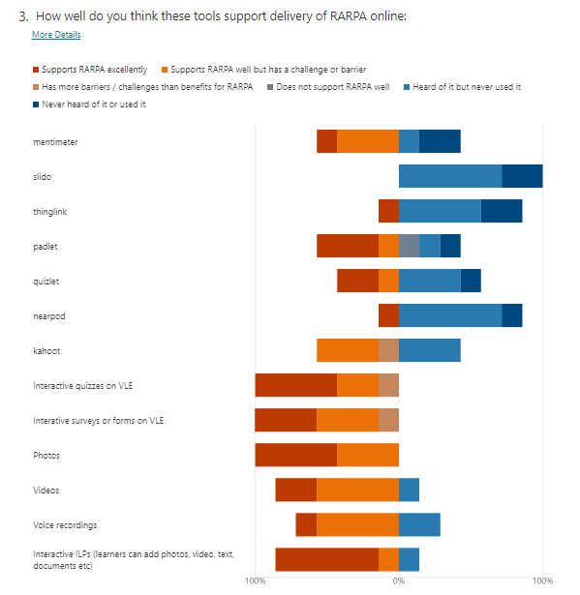

Q. How much impact do these barriers have on the RARPA tools you choose to use in your service, (where 6 is the most impact and 1 is no impact)?
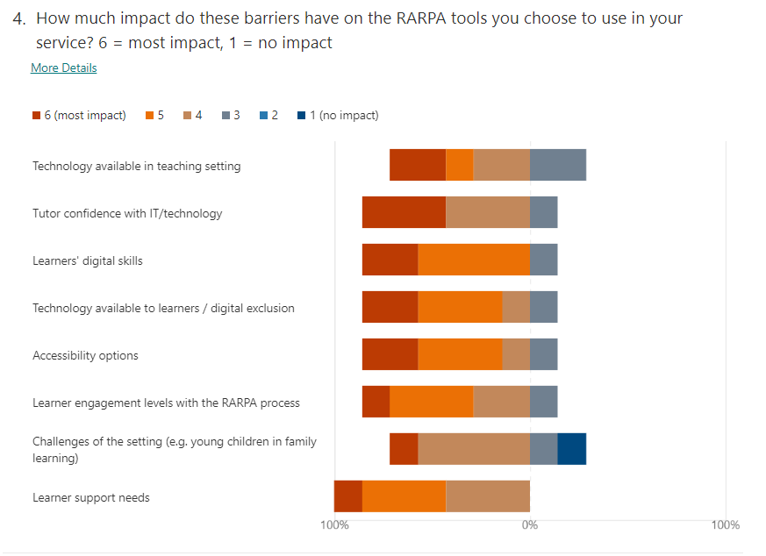

Q. When selecting a digital RARPA tool, how important to you are these qualities? Please rank them in order.
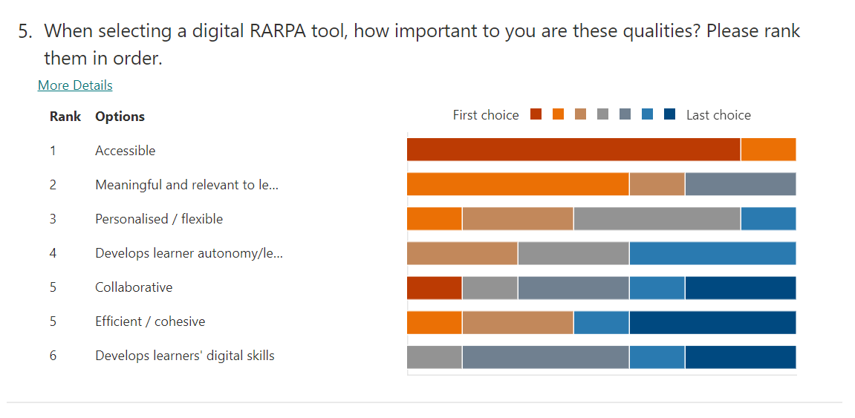

Q. Would you like to add anything else about using digital tools to deliver RARPA online?

My courses are all about hands on creative skills and learners don't always want to engage with technology - they see these courses as an opportunity to get away from computers.

There are so many tools and require a lot commitment and time to assess. For the time I have to dedicate to the ALC service, learning them and experimenting with them involves a prohibitive barrier of time. I am slowly experimenting and developing my ideas, but lets face it - even with my lifetime of experience working with computers (I took my first computing exam in 1997), this is an extensive task and too much to ask to really develop fully. In addition, most of these tools do not integrate well into G.Classroom or Teams (which is horribly clunky as a class and collaboration tool). Both Google and MSTeams work to the assumption that this area of work can be catered for from a single application. If that is so, then they have a lot of development work to do. This is because at present both applications have only got about 15% of the way to the sort of productivity levels I expect in this very diverse work area.

