

Digital Routes for work experience, traineeships and study programmes

Further Education Professional Development Grant – ACE Digital Leaders

Staff Network 2

Introduction
This document will look to propose ways to deliver work experience, traineeships and study programmes using digital routes, identifying possible digital routes to enhance the delivery.
The pandemic brought about a necessary change to move to online digital delivery at short notice. This study aimed to engage with a number of providers, via a series of facilitated online meetings, where experiences of the rapid transition to online delivery was discussed to determine what viable options had been identified for digital delivery. None of the contributors had previous experience of delivering online pre pandemic but all organisations responded quickly.
This study was hampered by sporadic attendance from a small group of contributors due to teaching commitments and it may have been better to do this within a different time frame when teaching wasn’t an impact on time (e.g., perhaps holding meetings during school holidays). In our three meetings we discussed our experiences and came to some conclusions as discussed.

Digital Routes Identified
We discussed the possible digital routes for work experience, study programmes and traineeships.
The key digital routes identified are listed below:
- Sharing of documents through Google or Teams and other platforms.
- Drop-in sessions – face to face sessions in classrooms to build basic digital skills before joining or participating on a programme
- Sharing videos – these can be used to prepare students for online delivery, giving them guidance on how to navigate the learning. They can be utilised to share working practices or demonstrations that students can access at any time they wish to view them.
- Online delivery – blended or online classrooms only
- E-learning – BKSB and The Skills Network, Future Learn
- WhatsApp or chat rooms – could be more utilised to encourage students to create their smaller subgroups to build their own communities.

Each of these digital routes is considered in more detail below:
- Sharing of documents, assessments and assignments, hosting resources and course work for programmes can be done relatively easily using Teams and Google. The work can be held safely and accessibly on these platforms, resources can be made accessible via dictation software, immersive reader and translators. Documents can be tracked and monitored and collaboratively worked on by all participants. Having the documents online also provides advantages in terms of distribution and ensuring that the latest version is always available.
- Drop-in sessions can be used to build digital and other skills to guide the learners on to the right path and to support them with the basic skills they will need to be able to participate on the programmes. Initial assessment and IAG sessions can support learners with SEND (Special Educational Needs) and the right support can then be identified for the course, whether it be a scribe, reader or dyslexia or dyscalculia or other support or devices. These sessions provide users with the confidence required for more structured online sessions and help to reduce barriers to entry.
- Sharing videos, depending on the audience these can be bespoke and appropriately made for induction and course familiarisation purposes, recording of demonstrations and work experience. These can be a relatively cheaply produced resource which make the learning accessible and relevant. In particular videos can be used as an entry point to other routes given that most learners, even those with relatively little experience, will likely have used platforms such as YouTube.
- Online delivery using Teams or Google this provides a space that classes can be held in safety and recorded for later reference and support. The group discussed both. Buckinghamshire used Google and found that resources could be copied and moved over for use within the google suite. Some learners needed to be contacted initially by text and phone to build a relationship and confidence before joining the actual courses. Tutors noticed that as confidence and skills grew the learners became less reluctant to use the camera in sessions. This gave the learners space to learn and develop, the tutor benefited from being able to be received automated updated on the completion of assignments. In Norfolk Teams was utilised in a similar way and in both areas tutors and learners can access resources and assignments in one place, saving time and confusion for all.
Challenges for the Teams users particularly with less confident digital skills was mainly access in the first instance as logging in can be difficult but this has mainly been overcome now by sending learners direct email invites and links which help them get started. We are however looking into creating some specific videos to introduce classes and guide people around Teams.
Challenges for Google users can be that they are learning two platforms at a time, as most businesses and organisations use Microsoft Office so when they learn how to use google sheets or google docs, they may have to adjust their knowledge to fit in with office products, however this does not take away their skills they’ve learned.
The importance of good information and guidance and support are crux of making the digital experience work. Learners need the correct level of support to participate whether with a specific LSA and the communication between tutor and LSA is paramount. As the LSA will struggle to support well if they don’t have the right information and are involved in the planning and reasoning behind activities.
- E-learning tools were discussed and BKSB and the Skills Network provide a good solid environment. In Norfolk the BKSB is used for initial and diagnostic assessments and used to support independent learning activities for blended courses. Learners are tracked and this gives the teachers a good overall group profile of activities and abilities. They can easily see what the members of the group have been working on and they are able to encourage those learners who are reticent using the tools.
- WhatsApp and chat rooms can be used to encourage the sense of community away from the classroom and can be used to help learners socialise and communicate with each other. While these collaborative tools were mentioned during discussions, it should be noted that usage among the study participants was limited.
Assessment and observations
Observations can be recorded through both platforms and enable storage which can be accessed by the Internal Verifiers and External Verifiers too. Due to the learners’ familiarity built over time in sessions they become more comfortable with recordings and presenting, giving them excellent transferable skills into employment and life.

Conclusion
The use of digital tools are of real benefit when used well with the right resources. They can be used to help trainees and learners become more employable through using their digital skills to the highest levels they can.
In addition to giving training providers alternative mechanisms, it is also noted that the use of these digital routes, whether as a replacement for or alongside traditional, classroom-based methods, has the advantage of providing learners with transferable digital skills in addition to whatever subject is being taught.
Although the remit of the study specifically mentioned “work experience, traineeships and study programmes”, it should be noted that no specific distinctions were identified during conversations. Clearly some routes may be more suited to some environments than others, but it was felt that all identified routes had some degree of relevance in each case.

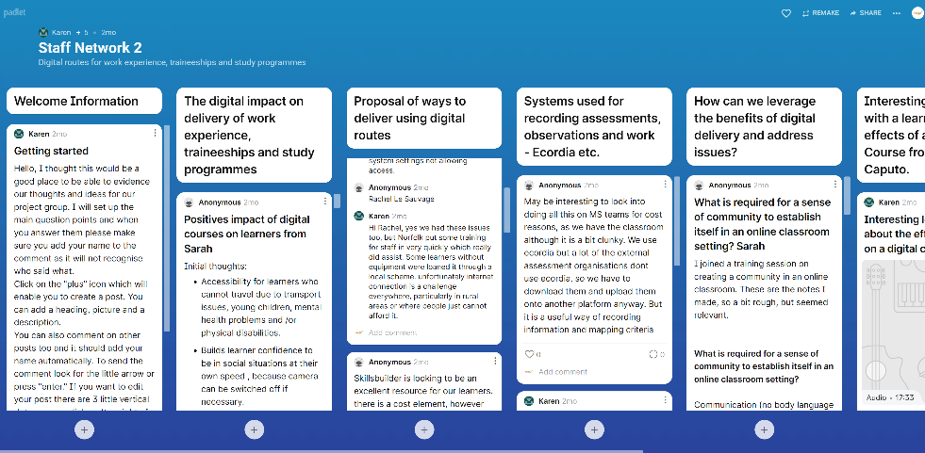
References
The staff network group used a Padlet to record and evidence their thoughts and ideas on various key discussion points.
This can be accessed here and includes a link to the case study recording which is summarised in the appendix.

Case Study summary – Learner experience of following a study programme online
The learner (referred to as SD from now on) was interviewed about the effects of following a study programme online. SD has physical illnesses and mental health problems that make attending classes very difficult. She was bullied at school, did not get any support with dyslexia problems and was treated badly. She had previously tried adult learning classes in class but found being in classroom intimidating, embarrassing and had severe anxiety and had to back out of evening classes.
SD feels much more comfortable and relaxed being online rather than in a classroom, as she is in her own, familiar surroundings. On the first day she was very nervous, didn’t like camera on - felt vulnerable, but then felt more at ease because she knew she could turn camera off.
Initially she didn’t know anything about Teams or how to use it. She recognises that this skill can be transferred to job interviews, etc. She was concerned about online safety but had lots of support from NCCAL initially about safety. She has never felt unsafe online during course and recognises the safeguarding in place and appreciates it. SD learned how to use the camera on her laptop and computer and how to do different backgrounds (also useful for interviews) - would feel happy doing an online job interview now. She was pleased to have dyslexia screening initially online, then at Kings Lynn.
She kept going with course because she felt at ease in her own environment and was given the space to take her time with the work. She found break out rooms very helpful as it was not so obvious to other learners that she was having problems. We used a special message in chat if she suddenly needed a breakout room and we could do this without drawing attention to the fact, whereas in a classroom we would have had to have got up and left the room.
SD enjoys the support she gets, the friendliness of everyone - she thinks this is due to the others also being at home and feeling more relaxed. She enjoys working in small groups because other people can’t hear what is going on and we can’t hear them. We can laugh more without disturbing others. She really liked the fact that she could spend the whole session with other people without having to wear a mask!
- She feels the course has been very worthwhile doing. She has learned how to research online and, because it is immediate, during feedback to the group she can learn from other learners’ research too. She much prefers the immediacy of this learning. She also likes the fact that the tutor posts forthcoming work online and she can download it and study it before the actual class.
- Since attending an online course she uses her computer much more and is considering setting up a business from home online.

