

Effective support for online learners who have mental health needs

Further Education Professional Development Grant – ACE Digital Leaders

Action Learning Set 5
Dr. Alexia Zinonos-Lee

At the start of the pandemic in March 2020, all learning was moved online, using platforms such as Zoom, Google Classroom and Teams. Although a lot of centres have now gone back to face to face learning, a significant number of courses have remained online. Some of the reasons for this are that learners have said that it is more convenient; it fits around family life a lot better and that they are saving money on transport, parking, childcare. Most importantly for the topic of discussion here, it has been found that those learners who are struggling with their mental health can continue to learn without having to leave their house which in some cases may cause a lot of anxiety for learners. Those with mental health needs have also expressed that learning online is more manageable for them and they would not be able to undertake the courses if they were face to face. It therefore is very important that we understand how to effectively provide support for our online learners who have mental health needs.
First and foremost it is essential that tutors remember what their role is and their boundaries within that role. They are not there to ‘fix’ their learners. It is essential that all tutors and support staff know where they can signpost learners in order for them to get the best possible support for their specific mental health needs. It would be brilliant if all staff/tutors could be trained as Mental Health First Aiders. This would give them the tools to spot the signs of a learner with mental health needs and identify when a learner needs help. It teaches individuals how to listen to a learner’s concerns and where to signpost them for the most appropriate support.
We felt that it is crucial that each organisation has a directory of local specialist support services where they can signpost learners with mental health needs. All tutors, staff and learners should have access to this directory. In this way, learners who felt able could self-refer to an organisation for specialised support. Staff and tutors could use this directory as a reference point to find the information about where to signpost their learners for support with their mental health needs. We thought we could utilise something like Google Classroom or a Padlet to make this available to all. One of the participants in the action learning set felt inspired after our meeting and put together an information sheet to this effect to share with other members of her Team and learners. (Appendix A)
We felt that in an ideal world, there would be a Mental Health Support Lead within each organisation. This would be the person that tutors could refer learners to if they felt the learners had any mental health needs. Tutors could also consult the advisor if they needed advice about a learner and they would be responsible for keeping the directory up to date. Ideally, they would be trained as a mental health first aider and be able to provide training to the other tutors and members of staff.
We also spoke about the possibility of Mental Health Support Assistants who could be assigned to support learners within the online classroom. Essentially, they could support learners who were feeling anxious about being in class, are struggling with their mental health and need a bit of support getting online and being in class. One of the issues discussed during our meetings was the stress that the technical side of learning online can cause some of our learners. We spoke about how we can reduce this stress for learners and thought that we could utilise technology to do so. Before the start of the course, we could send all learners a video with step-by-step instructions of how to get onto the online classroom, including pictures of what they will see on screen when signing in. It would also be great for the tutor to send a short video, introducing themselves to learners before the course starts. Having these before starting a course, would ease the anxiety some learners feel before their first sessions.
Offering short courses designed to help learners look after their mental health could not only help current learners but may help potential learners who may be struggling. It is hoped that by undertaking such a course, our present learners will be able to continue on their courses and potential learners would feel less anxious and more confident to attend more courses.
In our discussions during our workshops we concluded that one of the most important aspects that tutors can focus on for their learners is building a safe, positive and comfortable online classroom environment.
One of the ways discussed to achieve this is by having a casual chat as learners come online at the beginning of class. Some tutors open their online classrooms 15 mins before class so that learners can get on for a chat before the teaching begins. Other tutors lead the chat by speaking about TV programs, what they did on the weekend etc. Creating this casual, chatty environment in this way, will help with learners’ mental health as they will be connecting with others, but also helps learners feel comfortable enough with the tutor to disclose mental health issues if they need to.

We felt that discussions around mental health should be embedded in our teaching in the same way as British Values or Prevent are. Some effective ways we thought we could do this:
- asking learners how they are feeling (Ask Twice | Time To Change (time-to-change.org.uk)),
- speaking about ways to look after their mental health (5 steps to mental wellbeing - NHS (www.nhs.uk)),
- displaying a poster about how to de-stress/ways to take a break/the five ways to wellbeing either during the break or at the end of the session. (Appendix B)
- including wellbeing when discussing what support learners can get from learner support services
- getting learners to create a ‘mind plan’ which will give them ways to look after their mental health (Every Mind Matters - NHS (www.nhs.uk)).
In doing these things, tutors create a positive learning environment and form a relationship where the tutor becomes a safe person to speak to. They also help learners recognise the importance of looking after their mental health and gives them some tools to do this.
In some organisations, tutors have mentor groups which meet on a regular basis outside of the classroom. These online meetings are not necessarily learning related but a place for learners to chat with each other, make social connections and ask questions they perhaps don’t get a chance to during class time. In this way, learners can support each other (peer support) if they are having issues and tutors can get to know the needs of the learners in a more personal way.
We felt that it is important to give learners alternative ways of communicating and taking part during class. We know for some having their cameras on can be anxiety-inducing. We thought we could ask them to only have them on for a few minutes at the beginning/end of class. In this way the anxiety of having them on throughout the class is alleviated but they still have a more personal interaction with their peers. Another idea was to ask learners to have their cameras on but they don’t have to be in shot. They could then use a thumbs up/thumbs down, in camera to answer questions and interact with the class. It is the hope that they would then gain more confidence and eventually move into shot.
We should give them the options to write their answers in the chat rather than having to say them out aloud, answer with just a thumbs up or a thumbs down and even use emojis when asked how they are feeling. All of these alternative ways of communicating allows the learners who feel more anxious about talking in class to still take part and interact with others. It is also a recognition by the tutors that some learners may not feel comfortable speaking in front of other learners.
It was interesting to see the wide range of support available across the different organisations. A number of the tutors were already trained as Mental Health First Aiders. One participant was the welfare officer of the organisation, her role comprised of being lead for both safeguarding and learner mental health. Some organisations already had directories, in some cases these were accessible to learners as well as tutors and in others, tutors were not aware of these directories until they asked about them.
What is important to remember is that in order for tutors and staff to look after learner’s well-being, they need to also be looking after their own well-being and know where they can go to for support with this. They need to be able to discuss issues arising in class with their managers and know who they can speak to when learners come to them with mental health needs. Mental wellbeing needs to be recognised as an important issue organisation wide and support, be it in house or through referrals, needs to be available for learners and staff alike. In this way, we assure that all of the members of our communities are aware of how to look after and maintain good mental health and where they can receive support when they have mental health needs.

Appendix A - A directory for signposting learners for support with their mental health needs – see below screen shots of the resource and click here to access the pdf with working links.
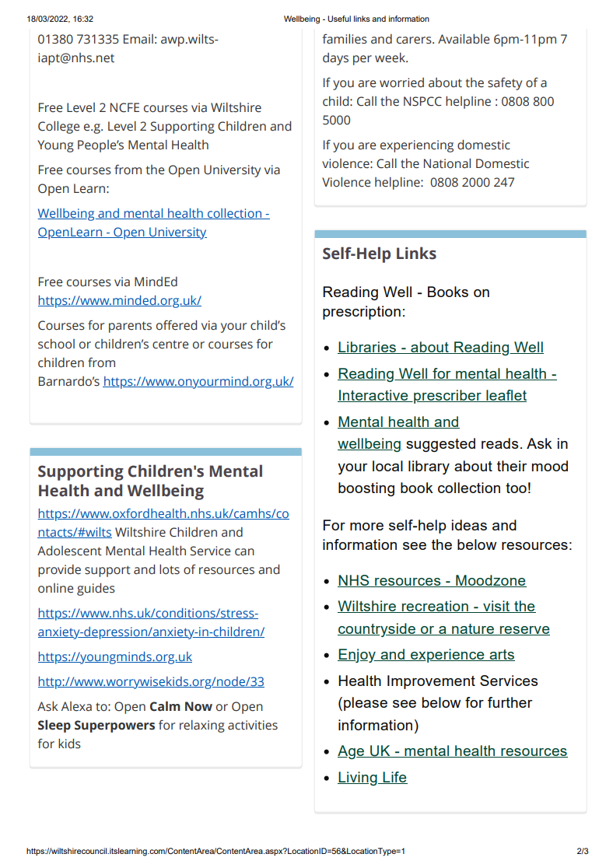
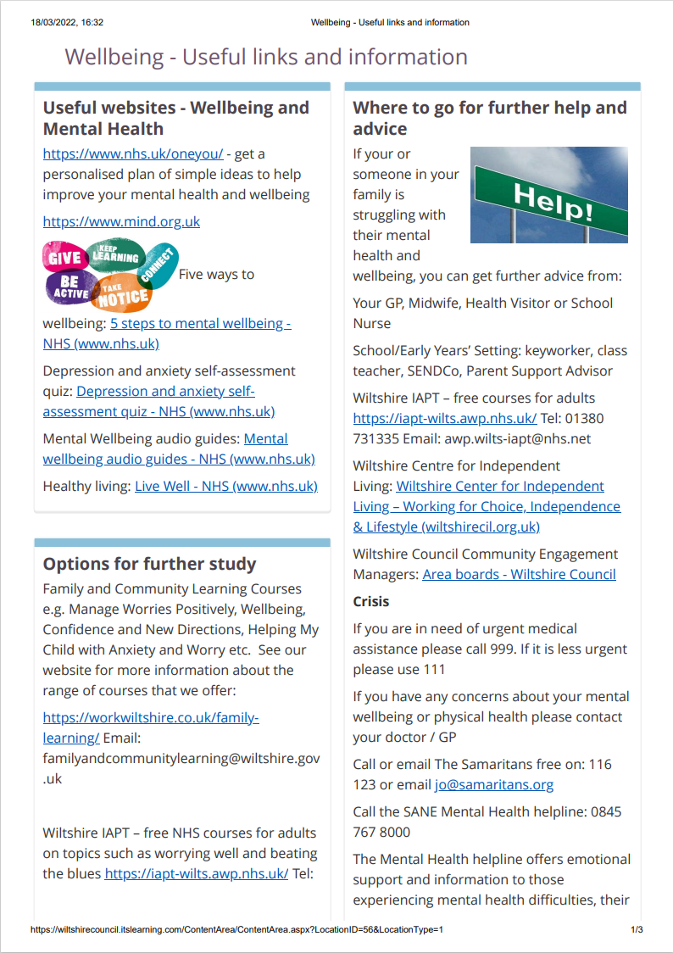

Appendix B – Examples of posters; how to de-stress/ways to take a break/5 ways to wellbeing
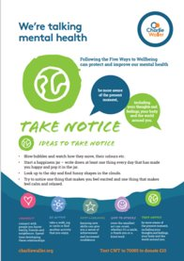
The Charlie Waller Library of Mental Health Resources
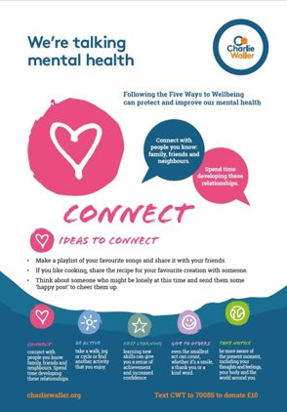

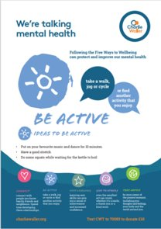

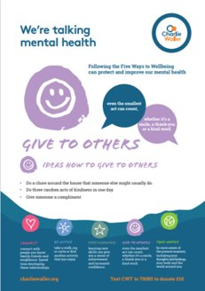
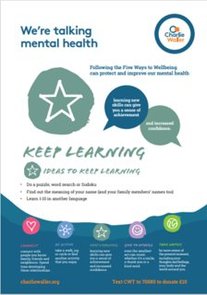

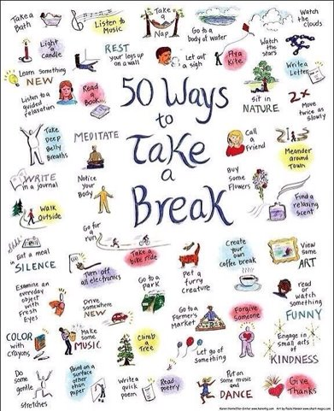
50 Ways to Take a break

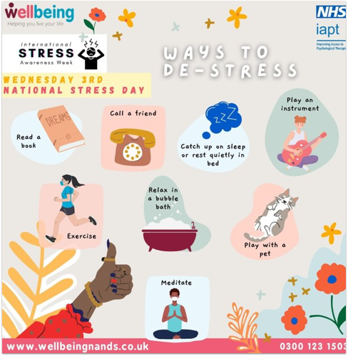

Ways to De-stress
www.wellbeingnands.co.uk

Appendix C - Case study
Sophia has signed up for a course with Norfolk County Council Adult Learning. She is anxious about learning as she did not have a very good experience at school but is now determined to get back into education. Along with an e-mail confirming her place on the course, she is sent a video with step-by-step instructions of how to sign on and join the online classroom. She is also sent a video from her tutor, introducing herself. This has alleviated some of her worries around getting online and how to access the classroom. Seeing her tutor also makes her feel less anxious as she seems friendly and approachable.
Once on the course, Sophia experiences the death of a close relative. She can’t seem to shake the feelings of sadness and despair and although she continues to go to her classes, she leaves her camera off and does not interact with her tutor or other learners. Her tutor sends her an e-mail saying that she has noticed this change in her behaviour and asking if she would like a one-to-one chat after class. Sophia likes her tutor and knows that she is supportive as she has heard how she has spoken to other learners who have expressed worries in the past. So she agrees to chat to her.
During their discussion after class, Sophia discloses how she is feeling to her tutor and tells her that she doesn’t know how to stop feeling this way. Her tutor recognises how difficult it is to deal with loss and asks her if she would like to speak to a professional about how she is feeling. She says she will think about it. After their chat, her tutor e-mails her with some contact details of organisations she can access who could offer her support. She also tells Sophia about some short courses that are being offered by NCC Adult Learning about looking after your mental health. Sophia thinks this is something she might do in the future but doesn’t feel up to it at the moment.
After self-referring to Wellbeing Norfolk, Sophia is offered a place in a support group with other people who are also grieving. She attends a few sessions and begins to realise that what she is experiencing is part of the normal grieving process. The leader of the group gives them some tips on activities they can do to deal with the grief and ways to celebrate her relative’s life. Sophia enjoys doing these activities and starts to feel more like herself again.
During class, her tutor speaks to the learners about the 5 ways to wellbeing and Sophia decides that she will go back to a yoga class that she used to go to but stopped during the pandemic. Although it takes a few months, Sophia starts to feel confident enough to put her camera on during the lessons again and even asks questions on camera rather than through the chat.

