

Applicant Role and Organisation Briefing

Membership and Operations Assistant
September 2024

Welcome to HOLEX
Thank you for your interest in the role of Membership and Operations Assistant and joining the HOLEX team.
HOLEX stands at the forefront of Adult Community Education (ACE), serving as the lead professional body dedicated to advancing the sector. Representing a network of 150+ ACE organisations, HOLEX is the authoritative voice for professionals working in local authorities, Institutes for Adult Learning, colleges, and independent third sector learning organisations. Together, HOLEX members annually educate, train, and retrain over 400,000 adult learners, earning recognition as sector leaders in teaching and learning quality.

About HOLEX
Background:
HOLEX was set up in 1993 in response to the 1992 Education Act which removed general further education from Local Authority control. Although colleges were moved out, each local authority was left with their adult education service and/or institution. The Act called these services Large External Institutions. Over time, adult education institutions have changed their names, but their role has remained the same. HOLEX was set up to support the Heads of those institutions, hence the name Heads of Large External (HOLEX) institutions. The infrastructure that supported adult education has since reduced and changed and its member organisations are looking to HOLEX for added advice and guidance. In response, HOLEX is now ready to grow into a new form.

Mission and Purpose:
All HOLEX members share a common mission: to provide skills and learning opportunities that empower adults and their families to succeed in life, supporting employment prospects and overall wellbeing. This collective effort not only enhances productivity but also fosters the conditions for economic success. As a member-led organisation, HOLEX's overarching purpose is to champion the ACE sector, enabling members to deliver high-quality provision that contributes to the economic, social, and wellbeing advancement of learners.

Current Context:
HOLEX is developing a strategic approach to expansion, with a view to growing our membership base, and moving into research and professional development programmes for the whole ACE sector. We believe that the policy we influence, the partners we represent and the learners who we shape, uniquely place HOLEX at the centre of a of England’s adult education landscape.
The organisation is presently run through a small but dedicated team and policy advice is provided by a forum of volunteers who are experts from within the sector. Being part of the team at a time of developing new ideas and ways of working is a great opportunity for a person looking to bring a fresh perspective whilst also being keen to learn and develop their own skills and expertise.

Governance and Membership:
HOLEX operates under the governance of the Association of Adult Education and Training Organisations (AAETO). The Board and Policy Forum, consisting of dedicated individuals from the sector, guide the organisation's activities. Full membership is open to ACE learning organisations receiving government funding, with tiered subscription fees based on total service income.

Delivering our Vision:
HOLEX’s purpose is met through several commitments:
- Cultivating a culture of lifelong learning for all.
- Developing inspirational leadership for a sustainable sector.
- Influencing policy and decision-making through sector promotion and advocacy.
- Driving change in the best interests of adult learners through a member-led network.
- Developing member networks and support mechanisms to foster quality delivery.
- Providing support for Heads of Service and Principals.

Services Provided to Members:
HOLEX extends a comprehensive array of services to its members, ensuring their continued success in the ACE sector:

- Policy Contribution: Proactive engagement in policy initiatives and advocacy for funding protection.
- Representation: Recognised as part of government consultation machinery, with involvement in national groups and regular meetings with key stakeholders.
- Policy Interpretation, Analysis, and Advice: In-depth analysis of government announcements, mapping their impact and offering practical advice.
- Network Development Events: Three free network events annually for sharing best practice and insights from national experts.
- Webinars: Regular webinars on topical issues to keep members informed and engaged.
- Newsletters and Round-ups: Monthly Policy Round-ups and summaries of national initiatives to keep members informed.
- ACE Digest: Regular updates on research, policy, and practice in ACE.
- Case Work: Addressing individual service or centre issues with funding bodies and relevant authorities.
- Facilitating Peer Support: Email network groups for quick issue resolution and knowledge sharing.
- Involvement in Externally Funded Development Activity: Bidding for and managing development projects aligned with member support needs.
- Sharing Information: Dissemination of new initiatives, job vacancies and training opportunities.
- Additional Benefits: Membership counts as membership of a professional body, leading to potential discounts.

HOLEX Structure

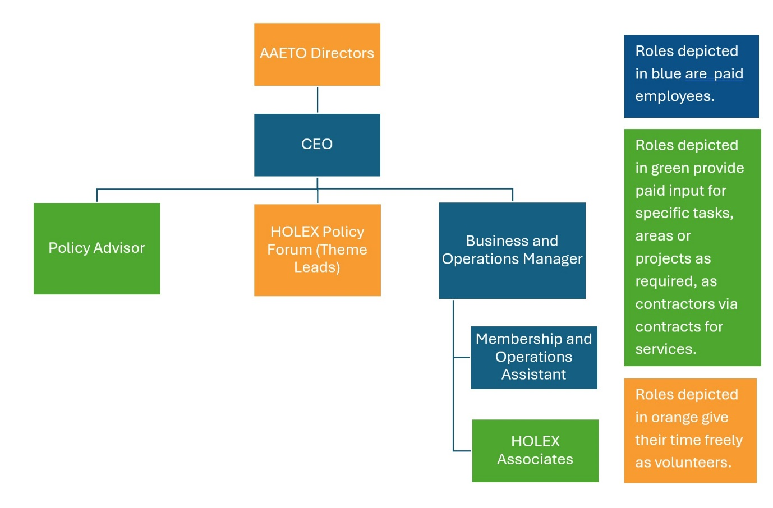

Job Description

Job title | Membership and Operations Assistant
Reports to | Business and Operations Manager
Responsible for | N/A
Salary | £15,000 per annum (Equivalent to £25,000 FTE)
Hours | 21 hours per week (0.6 FTE).  Flexible days to agree with line manager.  Scope to increase hours in the future (to align with business growth).
Contract | 2 years initially with extension in development. Potential to increase hours.

Purpose of the job
The position of Membership and Operations Assistant at HOLEX is an exciting opportunity for someone looking to be a key part of a small, dynamic team within the adult education sector. This role provides a chance to gain experience in various areas, with a focus on administration, events, and communications.
Key aspects of the role include:
- Membership Engagement: Providing a professional service to members by responding to enquiries, maintaining records, and ensuring the satisfaction and growth of the organisation's membership.
- Administrative Support: Assisting with the day-to-day running of the organisation, providing clerical and operational support to ensure the smooth functioning of HOLEX's activities.
- Information and Communications: Delivering an engaging communications plan that promotes HOLEX and its members. This will involve managing our website, social media, newsletters, and creating other promotional materials.
- Events Planning: Organising events that raise awareness of HOLEX's strategic priorities and to support its membership. This could include planning logistics, liaising with stakeholders, and ensuring the success of events.
- Collaboration with Leadership: Working closely with senior management to support the strategic goals of HOLEX, ensuring operational efficiency and contributing to the overall success of its activities.
This role is ideal for someone who is organised, has strong communication skills, and is eager to contribute to the growth of a meaningful organisation in the adult education sector. Full support and training will be provided, making it a great opportunity for professional development.

The Role
This role is pivotal in supporting and strengthening the adult and community education sector through network building, advocacy, and skill and knowledge development.
As part of a small team, this role will assist with the smooth-running of activities on behalf of HOLEX members as well as supporting broader strategic strands. You will need to have a flexible approach to work, the ability to multitask, maintain a friendly approach under pressure and be able to demonstrate your commitment to the role, ensuring high levels of customer service, with excellent attention to detail. The role requires a tech-confident, highly organised person to help with membership development, intelligence gathering within the adult education sector and profile raising. A high level of accuracy and attention to detail is required along with a good working knowledge of communication and publicity channels.

Ways of working
We work remotely, with opportunities to come together in person to work, plan and develop. There are also in-person events run during the year across England, some of which you will be expected to attend.
The work is varied, requiring rapid processing of information, and the ability to act confidently with multiple and senior stakeholders including heads of service, board members and government-based colleagues.
Key Benefits
- 16.8 days annual leave (based on pro rata of FTE 28 days), plus pro rata bank holidays
- Pension scheme, employer contributing 5% of salary
- Flexible and fully remote working
- Homeworking allowance
- Access to training and development opportunities.

MAIN DUTIES

Membership engagement  Build and maintain strong relationships with HOLEX members and relevant bodies outside the membership | Provide a "first point of contact" service acting as the initial representative who handles enquiries from members and external partner organisations.  Retain existing members and help recruit new members by sharing information on our work and describing the benefits of membership.  Ensure our members are active, engaged and fully utilising their membership.  Ensure membership data is being captured effectively to grow our database and track membership statistics; use data to improve services and provision of activities.  Manage the annual membership renewals process, new applications and the onboarding process.  Support the gathering and dissemination of sectoral information and developments with a view to creating relevant briefing materials.
Information and Communication  Develop and deliver effective communication tactics that ensure stakeholders receive timely, accurate, and responsive information through various channels. | Website - update and manage website content. Monitor website performance and user feedback to continuously improve the site’s functionality and user experience.  Post new content, revise existing pages, and collaborate with team members to ensure that the website reflects the latest updates, announcements, and organisational changes.  Support the development of website improvements. Provide a proactive approach to upgrading and improving its functionality for members.  Social media - Develop and maintain our social media platforms with a view to increasing our reach online. Ensuring that all information is accurate, current, and engaging.  Utilise marketing and communication platforms (e.g., Survey Monkey etc) to collect and disseminate information.  Edit and distribute monthly and quarterly briefings and newsletters.  Support team members in the production of publicity material such as publications, CRM emails or other collateral.
Events planning  Deliver the logistics and planning for network events, webinars and other member facing activities. | Lead on the end-to-end logistics, technology, and communication in establishing and delivering online and in-person events.  Liaise with stakeholders to ensure successful delivery.  Set up and administrate online events, including supporting live delivery.  Contribute to the management of an events calendar.  Collect and analyse feedback so as to evaluate event success and identify areas for improvement.
Administration Support  Provide support to the smooth running of general administrative functions | Financial administration including data entry, invoicing, expense tracking, and payment processing, ensuring that accurate financial records are maintained.  Ensure that HOLEX’s contact database is kept updated. Manage and maintain our e-group membership.  Maintain a record of requests or highlighted issues/queries from members.  Evaluation of data or reports when relevant to members.  Support members and partners to get involved in research, projects or networks on issues that are important or useful to them.
Work as part of the team | Contribute to team meetings and the development of organisational priorities.  Support the CEO in managing their dairy and wider meeting requirements.  Proactively present ideas and make recommendations to improve and enhance HOLEX’s work and presence.
Additional conditions | Over time, the nature of individual jobs will change; existing duties may be lost, and other duties may be gained without changing the general character of the duties or the level of responsibility entailed. Training and support will be provided where necessary.  The CEO will revise this job description as required and will consult with the post holder at the appropriate time.  The nature of the job means that hours may need to be worked flexibly and this may include occasional weekend and evening work. This will be discussed and agreed in advance.  In addition to the contracted work above, there is likely to be the opportunity to get involved in externally funded project work; a willingness to be involved in this would be beneficial (with additional payment to compensate for additional input).

WORKING RELATIONSHIPS & CONTACTS

Critical to this role will be the building of effective relationships across HOLEX, the wider membership and key stakeholders:

Internal:
- CEO
- Business and Operations Manager
- Board of Directors
- Policy Forum members

External: (examples)
- Regular contact with HOLEX members to provide a high quality and responsive membership service
- Regular contact with contractors who provide operational support to the organisation
- Contact with stakeholders including Government departments, Education & Training Foundation, Association of Colleges etc.

Work as part of the team:
- Contribute to team meetings and the development of organisational priorities
- Work effectively as part of a small team including, where necessary, standing in for other team members.

General Responsibilities:
- To adhere to HOLEX’s Equal Opportunities policy in all activities, and to actively promote equality of opportunity wherever possible
- To be responsible for your own health and safety and that of your colleagues, in accordance with the Health and Safety at Work Act (1974) and relevant EC directives
- To work in accordance with HOLEX’s data protection policies, and relevant current data protection legislation.
- To undertake such other duties as may be reasonably expected.

HOW TO APPLY
Interested candidates should send a full CV and supporting statement addressing the person specification. We also want to know how you believe you meet the requirements of the role, why you are interested in this job, and what attracts you to HOLEX in particular.
Your statement should be no longer than 1500 words long. Email your documents to charlie.mckenna@holex.org.uk
If you would like an informal chat about this job, please contact charlie.mckenna@holex.org.uk.
The closing date for applications is 5pm Wednesday, 9th October.
Interviews for successful applicants will be held online on Monday, 21st and Tuesday, 22nd October 24.

