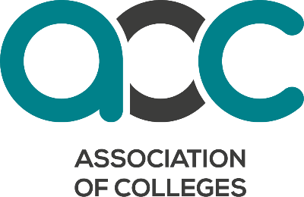
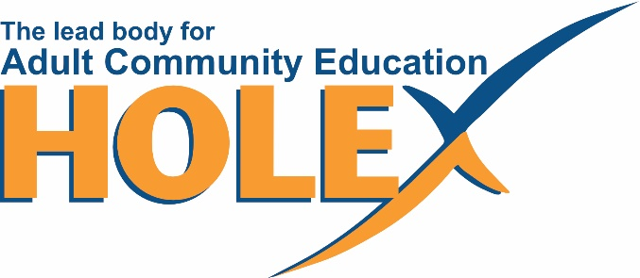

Sector Guidance on the Purpose and Outcomes of Tailored Learning

Contents
- Summary
- Tailored Learning - Definition
- Background
- New Learner Led System
- Purposes of Tailored Learning
- Learning Aims
- Outcomes of Tailored Learning
- Recording process
- Assessment processes
- Leisure Learning and Social Prescribing
- Explanatory note on the type of evidence for Tailored Learning Outcomes
Links and References

Annex 1 Purpose and Outcomes
Annex 2 RARPA Process
Annex 3 Combined Authority Approaches
Annex 4 Working group
Annex 5 Consultation Respondents

Guidance on Purpose and Outcomes of Tailored Learning
- Summary
This guidance sets out the purposes and outcomes of the government policy on Tailored learning and expands on how to demonstrate the learner purpose and outcome have been met. This guidance has been developed by the adult community education sector with the support of the Association of Colleges (AoC), Mayoral Combined Authorities (MCAs), Greater London Authority (GLA) and Department for Education (DfE).
This guidance is for all learning organisations who are in receipt of Tailored learning funding from the Education and Skills Funding Agency (ESFA) or MCA/GLA. There will be variations in some MCA areas and the GLA, however the principles are still pertinent to all adult education and skills provision and the vast majority MCAs and the GLA are using the 7 purposes and the 10 outcome areas of Tailored Learning.
It should be noted that the majority of learning organisations who receive ESFA Adult Skills Funding (ASF) Tailored Learning also receive income from the Skills element of the ESFA ASF and/or MCA/GLA. In addition, they may also receive Apprenticeship Levy and funding from other government departments, for example for ESOL programmes.
This guidance is only for the Tailored Learning element of ESFA/MCA funding, but the good practice described on defining and monitoring outcomes could support all adult education and skills programmes.
- Tailored Learning Definition
Since 2022, DfE have been developing a new approach to adult community learning funding and how it can best respond to learners’ and employers’ needs.
As part of the new Adult Skills Fund, for ESFA funded provision, the term Tailored learning brings together what was:-
- AEB community learning,
- Formula-funded AEB non-regulated learning (previously delivered through adult skills budget) and
- Any new employer-facing innovative provision that is not qualification based.
Some devolved areas may take a slightly different approach this could include choosing not to transfer all the formula funded non-reg and employer-facing provision to Tailored learning. The GLA and MCAs will continue to develop their approach as they respond to emerging local need that can be addressed with Tailored Learning. It is also worth noting that some of the newer MCAs will be adopting the ESFA funding, whilst they consult on their Adult Skills Strategy.
Please refer to your MCA or the GLA local funding rules (see Annex 3).
Some devolved areas may take a slightly different approach and may chose not to transfer all the formula funded non-reg and employer-facing provision to Tailored learning.
The DFE ESFA definition of Tailored Learning is –
As set out in the ASF funding rules for ESFA funded provision “the primary purpose of tailored learning is to support learners into employment and to progress to further learning, in line with the overall purpose of the ASF. It will, however, also support wider outcomes including using it to improve health and wellbeing, equip parents/carers to support their child’s learning and develop stronger and more integrated communities”.
Some GLA/MCAs have nuanced this definition, which can be seen in Annex 3 or by following the link to their funding rules.
- Background
DfE have collaborated closely with the adult education sector to optimise the allocation of the community learning budget considering modern lifestyles and the diverse and difficult challenges individuals face. The term "Tailored Learning" was selected to capture the imperative for adaptability and responsiveness to the specific needs of learners and employers, ensuring that funding is directed effectively towards supporting these objectives. The funding is expected to be responsive to local needs, guiding learners through a progression journey. This includes signposting, outreach and initial engagement, purpose documentation, delivery of learning objectives, additional support as necessary, and acknowledgment of their achievements with recorded outcomes.
The 2023/24 funding guidance set out 7 new purposes and the 2024/25 funding guidance expanded the purposes to describe the 10 outcomes that could be achieved by participating in Tailored Learning. These 10 outcomes run alongside the sector accepted outcomes of progression and employment.
New Learner Led System
The new system is made up of four parts-
- Determining the learner purpose/intent.
- Recording the learning aim.
- Documenting the actual outcome.
- Underpinning the process with robust internal guidance and quality processes.
Together they form a progressive educational and skills offer that puts the learner and employer in the driving seat, underpinned by the professional judgement and views of the teacher, and learning organisations’ quality process.
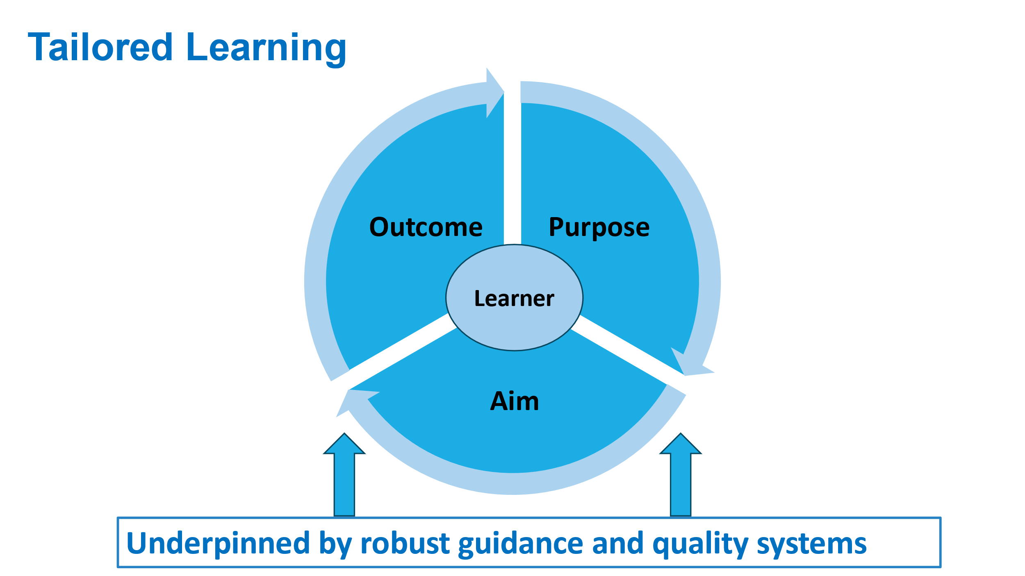

- Purposes of Tailored Learning
Seven purposes of Tailored Learning have been developed, related to the learner initial participation intent.
Learning organisations are expected to record on the ILR one purpose for each learning aim. The purposes were designed to recognise the wider benefits of learning and will be underpinned by a set of learning aims and recognised outcomes for learners.
Purposes-
- Engaging and/or building confidence
- Preparation for further learning
- Preparation for employment
- Improving essential skills (English, ESOL, maths, digital)
- Equipping parents/carers to support children’s learning.
- Health and well-being
- Developing stronger communities

The ILR requires learning organisations to determine one purpose per learner per learning aim. This will reflect the learner's primary initial participation intent (their intended outcome at the start of the course). If they have multiple purposes (as many learners do), the ILR requires the learning organisation to pick the main one. DfE are considering that in future years this may be opened up to two purposes, for example, improving essential skills and preparation for employment.

Learners studying on the same course may have different purposes. For example, a learner may participate on a course within the learning aim “Creative Arts” to improve their confidence, and another to prepare for further learning. Similarly, a learner may participate on a course within the learning aim “volunteering, active citizenship” to develop employability skills, and another to contribute to community life.

- Learning Aims
The 7 purposes listed above are underpinned with a new set of learning aims. DfE have worked with the sector to expand the list which now contains over 125 learning aims. The new list builds on the list available for 2023/24. Annex 3 details the listed aims for Tailored Learning for 2024/25. If you require a new aim, contact DfE.

MCAs/GLA will be able to record their non-regulated formula funded learning aims under the formula funded part of the Individual Learner Record (ILR).

The list of learning aims for Tailored Learning has been expanded to ensure it reflects what is currently formula funded non-regulated provision, and new employer-facing provision.

To find a learning aim

All the new learning aims have ‘tailored learning’ in the title.

The full DfE list of Tailor Learning learning aims is available here - https://www.gov.uk/government/publications/tailored-learning-learning-aim-class-codes.

You can also access them via these routes below:

- Download the LARS database: submit-learner-data.service.gov.uk/find-a-learning-aim/DownloadData The easiest way to find tailored learning is to filter the learning aim ref title on ‘tailored’.
- Search under ‘tailored’ on Find a learning aim. This should give you the list: Qualification search results (submit-learner-data.service.gov.uk)

- Tailored Learning Outcomes
The seven purposes are related to the learner initial participation intent and, through the recruitment process, learning organisations are expected to record on the ILR one purpose for each learner. However, it is recognised that once a learner progresses on a programme, their desired outcome may change. The learner’s final outcome at the end of the course does not need to tie in with their original purpose. For example, their journey begins by seeking to improve confidence, but the learner feels their end outcome is ‘improved skills for progressing to further learning’.

DfE recognise that learners may achieve in more than one outcome area, but learning organisations are asked to record one only:-
The outcome areas as documented in the ILR documentation are:-
- Increased confidence - Improved belief, or reduced doubt, in ones’ abilities.
- Improved skills for progressing to further learning - Skills to enable learners to progress to further learning; and can include generic skills such as study skills and/or sector specific or technical skills.
- Improved skills for work - Skills to enable a learner to gain and sustain employment; and can include generic employability skills and/or sector specific or technical skills.
- Improved essential skills - Essential skills are defined as English (or ESOL), maths and digital skills.
- Improved ability to support a child’s learning - Parent/carer more active in the support of their child’s learning and development, and better equipped to support and encourage their children’s learning.
- Improved physical health - Improved or maintained physical health. Maintained physical health is where health would have deteriorated without the learner participating in the learning programme or engagement.
- Improved mental health and well-being - Improved or maintained mental health and well-being. Maintained mental health is where health would have deteriorated without the learner participating in the learning programme or engagement.
- Improved skills to participate in community life - Learners have the knowledge and skills to take an active role in their local community.
- Increased understanding of democratic values - Learner understands the fundamental British values.
- Improved skills for Independent Living - The skills that learners need to live a life with agency; usually with a focus on life outside of work.
- No Outcome Area – the learner has completed or withdrawn from learning without achieving any of the Outcome Areas 1-10.

Learning organisations should record the outcome when the learner completes or withdraws from the learning activity.
Learning organisations should record the outcome of learning for each individual learner using one of the 11 attribute codes. The outcome area does not need to match the purpose type. DfE want to ensure there is flexibility for a learner to achieve in an outcome area that may not directly correspond to their primary purpose for learning. For example, a learner may have started a course to support their child’s learning, but their primary outcome area could be an improvement in their maths or English. The type of evidence proposed is described in section 11 of this document.
DfE intends to produce new data dashboards building on what they have done in 2023/24. These dashboards will contain information gained from the ILR on purpose, learning aim and outcome. The database will be open and will provide data for each learning organisation. 2023/2024 data can be found here:- Microsoft Power BI.
- Recording the outcome on the ILR
It is envisaged the ILR (Individualised Learner Record) captures the learner's primary learning objective/intent through its seven purpose types.
The ILR Outcome Area field will document the actual learning outcomes achieved, categorised into ten distinct outcome areas. Only the primary outcome area will be recorded on the ILR.
Tailored Learning Outcome Area: ILR Field
- Definition: The outcome of the learning for the learner when they have completed or withdrawn from the planned learning activities.
- Reason Required for ILR field: To demonstrate how Tailored Learning is supporting learners to achieve positive outcomes.
- Attribute Codes: Learning organisation to tick one of the ten outcome statements.
- Unknown Outcome: If the outcome is unknown, learning organisation should tick 11.

Definition
Code Definition
1 Increased confidence
2 Improved skills for progressing to further learning.
3 Improved skills for work
4 Improved essential skills
5 Improved ability to support a child’s learning.
6 Improved physical health
7 Improved mental health and well-being
8 Improved skills to participate in community life.
9 Increased understanding of democratic values
10 Improved skills for Independent Living
11 No outcome area 1-10 achieved.

Further Information can be found here - ILR Specification 2024 to 2025: Field: Tailored Learning Outcome Area (submit-learner-data.service.gov.uk)
For recording Family Learning the link is- ILR Specification 2023 to 2024: Attribute: Community Learning which is Family learning (submit-learner-data.service.gov.uk)

- Assessment processes that will support the judgement.
The assessment of whether a learner has achieved a specific outcome area should be determined via the learning organisation’s own assessment methodologies. The processes involved may vary across learning organisations but should maintain the necessary quality and rigour to ensure confidence in the recorded outcome areas on the ILR upon course completion. It is expected that the evidence will come from learner reflections and teacher observations and will be moderated through internal quality processes.
ESFA, MCAs and Learning organisations are encouraged to leverage their existing quality assurance and delivery processes to determine learner achievement within specific outcome areas. It may be necessary for learning organisations to adapt their assessment processes to adequately evaluate certain outcomes within an outcome area.
The sector is already accustomed to using different processes, for example-
- Recognising and Recording Progress and Achievement (RARPA).
- Individual Learning Plans: Assessing learner knowledge and skills at the beginning and end of the course.
- Provider Learner Surveys: Pre- and post-course questionnaires.
Every assessment of an outcome area should involve input from the learner, the tutor assessment based on classroom engagement or evaluation of learner work. Furthermore, learner self-assessment and peer-to-peer assessment can be valuable additions to the evaluation process. It is not envisaged that any other data is collected from other bodies such as a health authority.
Learning organisations should gather this information at conclusion of the course, as part of their routine procedures for determining whether learners have met their intended learning objectives. There is no requirement for learning organisations to continue follow-up after learners have left the institution for the purpose of filling in the ILR. However, the Ofsted handbook is very clear that they expect learning organisations to understand the impact of their courses on learners, short and long-term, including whether learners are going to appropriate and high-quality destinations. They are also clear about the sources of evidence that inspectors will gather, which includes what happens to learners when they leave the provider. That might be difficult for providers to do if they do not contact learners who have left.

The outcome area does not need to directly correlate with the purpose type, although often there is a connection. This flexibility allows learners to achieve outcomes that may not align directly with their primary intended objective. For example, a learner initially enrolling to support their child's education may achieve a primary outcome area related to improving their mathematics or English proficiency.

- Leisure Learning and Social Prescribing
As set out in the ASF funding rules for ESFA funded provision the primary purpose of tailored learning is to support learners into employment and to progress to further learning, in line with the overall purpose of the ASF. It will, however, also support wider outcomes including using it to improve health and well-being, to equip parents/carers to support their child’s learning and to develop stronger and more integrated communities.
For ESFA funded ASF provision, learning organisations should not use Tailored Learning funding for learning that is primarily or solely for leisure purposes, which is defined as learning where the primary or sole intent of the learning is for leisure. This applies to curriculum intent and to the learner’s purpose for undertaking the learning.
However, learners studying on the same course may have different purposes. For example, a learner may participate on a course within the learning aim “Creative Arts” to improve their confidence, and another to improve their well-being. Similarly, a learner may participate on a course within the learning aim “volunteering, active citizenship” to develop employability skills, and another to contribute to community life.
There is also no reason why courses that run at full fee cost for leisure learners could not accommodate TL learners who need, for example, to integrate into society or improve their mental health and are signposted through a social prescribing route.

- Explanatory note on the type of evidence that could be used to demonstrate outcome achievement.
To ensure the integrity of the process learner, outcome evidence will need to be collected. This section details the type of evidence that could be used to demonstrate outcome achievement. To ensure its reliability, this evidence will be drawn from a multifaceted approach, including insights collected from learner reflections and thorough observations by teachers. These components will then be moderated via internal quality processes (such as RARPA), ensuring a comprehensive and robust assessment framework.
Outcome area 1: Increased confidence

DfE Definition: Improved belief, or reduced doubt, in ones’ abilities.

Example outcome statements
By the end of the programme, the learner has …
- Increased their confidence in a named or specified area/skill.
- Greater positivity about their own life, situation, family etc.
- More willingness to engage in learning.
- Enrolled on a course of further study that they had previously not considered or declined.
- Commenced voluntary activities that they had previously not considered.
- Engaged with other publicly funded services they had not been engaged with previously.
- Started applying for jobs or for better paid jobs.
- Started working when they had not been previously.

Outcome area 2: Improved skills for progressing to further learning.

DfE Definition: Skills to enable learners to progress to further learning; and can include generic skills such as study skills and/or sector specific or technical skills.

Example outcome statements
By the end of the programme, the learner has …
- Progressed to further learning.
- Increased willingness and motivation to learn.
- Improved self-reflection and evaluation skills
- Improved organisation and self-management skills.
- Improved critical thinking and creative inquiry skills.
- Improved sector specific (technical) skills.
- Improved metacognitive skills.
- Improved ability to learn independently.
- Improved resilience in overcoming setbacks/obstacles in learning

Outcome area 3: Improved skills for work

DfE Definition: Skills to enable a learner to gain and sustain employment; and can include generic employability skills and/or sector specific or technical skills.

Example outcome statements
By the end of the programme, the learner has …
- Gained employment, voluntary work or work experience.
- Improved communication skills.
- Improved planning and preparation skills.
- Improved collaboration and teamwork skills.
- Improved decision-making and problem solving.
- Improved self-appraisal and development.
- Improved initiative and goal setting.
- Improved sector specific (technical) skills
- Improved career planning, and/or job search skills.
- Increased confidence about finding/getting a job.
- Increased motivation to look for work.
- Started looking for work.
- Taken steps towards self-employment.
- Progressed in their current employment.

Outcome area 4: Improved essential skills

DfE Definition: Essential skills are defined as English (or ESOL), maths and digital skills.

Example outcome statements
By the end of the programme, the learner has …
- Increased capability in any of the following: English (including English for speakers of Other Languages), maths, and digital.
- Gained a qualification within English (or ESOL) maths and digital.
- Progressed to learning at a higher level within essential skills (non-regulated or regulated) including English (or ESOL), maths and digital.

Outcome area 5: Improved ability to support a child’s learning

DfE Definition: Parent/carer more active in the support of their child’s learning and development, and better equipped to support and encourage their children’s learning.

Example outcome statements
DfE Definition: Parent/carer more active in the support of their child’s learning and development, and better equipped to support and encourage their children’s learning.

Example outcome statements

By the end of the programme, the adult learner has …
- Increased ability to read with child at home
- Increased ability to engage with children’s learning
- Increased aspirations for their child’s future
- Increased ability to embed learning in the home environment
- Increased ability to support school aged child to complete homework
- Increased ability to understand how children learn
- Improved family relationships

By the end of the programme, the child has …
- Improved engagement in learning and/or attainment
- Improved attendance
- Improved behaviour
- Improved readiness for school
- Increased aspirations
- Increased confidence to learn
- Improved social relationships

Outcome area 6: Improved physical health

DfE Definition: Improved or maintained physical health. Maintained physical health is where health would have deteriorated without the learner participating in the learning programme or engagement.

Example outcome statements
By the end of the programme, the learner …
- States they have improved mobility enough to apply for work or take on a skills course.
- Increased participation in employment, e.g. returned to work after sick leave.
- Increased participation in employment, e.g. returned to work after sick leave.
- Increased fitness levels, e.g. less out of breath going upstairs.
- Increased commitment to on-going activity, e.g. exercise classes,
- Improved understanding of the importance of diet and exercise to health.
- Visited the GP less.

Outcome area 7: Improved mental health and well-being

DfE Definition: Maintained mental health is where health would have deteriorated without the learner participating in the learning programme or engagement.

Example outcome statements
By the end of the programme, the learner has …
- Improved ability to manage mental health and well-being, e.g. anxiety.
- Made new friends.
- Reduced feelings of loneliness or isolation.
- Reduced levels of stress / anxiety / depression.
- Increased resilience
- Increased confidence and/or ability to seek employment or further training.
- Increased participation in employment, e.g. returned to work after sick leave.
- Increased well-being
- Reduced incidence and/or severity of the symptoms of a long-term mental condition, e.g. dementia.
- Increased sense of self-worth - 4 metrics of health from the ONS.

Outcome area 8: Improved skills to participate in community life

DfE Definition: Learners have the knowledge and skills to take an active role in their local community.

Example outcome statements
By the end of the learning, the learner has …
- Increased connectedness to the local community / sense of belonging to their community.
- Increased confidence to take action in the local community.
- Started to participate in community activity (e.g. volunteering)
- Met new people / made new friends within a local community.
- Increased understanding of their role in protecting the environment
- Developed sustainability (‘green’) skills.
- Created work that contributes to / enriches local cultural and community life.

Outcome area 9: Increased understanding of democratic values

DfE Definition: Learners understand the fundamental British values.

Example outcome statements
By the end of the programme, the learner has …
- Increased awareness and understanding of fundamental British values: of democracy, the rule of law, individual liberty, and mutual respect and tolerance of those with different faiths and beliefs, and principles that support equality of opportunity for all.
- Built connections with people they would not normally have met.
- Increased understanding of and respect for other cultures, including issues of equality, diversity and inclusion.
- Increased understanding of their own, and others’, rights and responsibilities.

Outcome area 10: Improved skills for Independent Living

DfE Definition: The skills that learners need to live a life with agency; usually with a focus on life outside of work.

Example outcome statements
By the end of the programme, the learner has …
- Improved ability to care for self and others.
- Improved ability to undertake personal and domestic tasks.
- Improved ability to make choices, use judgement and to problem solve.
- Increased financial awareness and money matters.
- Improved social interaction.

Outcome Area 11:
DfE Definition: the learner has completed or withdrawn from learning without achieving any of the Outcome Areas 1-10.

Links and References
Link - Adult skills fund: funding rules for 2024 to 2025 - GOV.UK (www.gov.uk)

Tailored learning can be found here- Adult skills fund: funding rules 2024 to 2025 - GOV.UK (www.gov.uk)

Annex 1
Purpose | Outcome
1. Engaging and/or building confidence | 1. Increased confidence
2. Preparation for further learning | 2. Improved skills for progressing to further learning
3. Preparation for employment | 3. Improved skills for work
4. Improving essential skills | 4. Improved essential skills
5. Equipping parents/carers to support children’s learning. | 5. Improved ability to support a child’s learning
6. Health and well-being | 6. Improved physical health  7. Improved mental health and well-being
7. Developing stronger communities | 8. Improved skills to participate in community life  9. Increased understanding of democratic values
 | 10. Improved skills for Independent Living

Annex 2

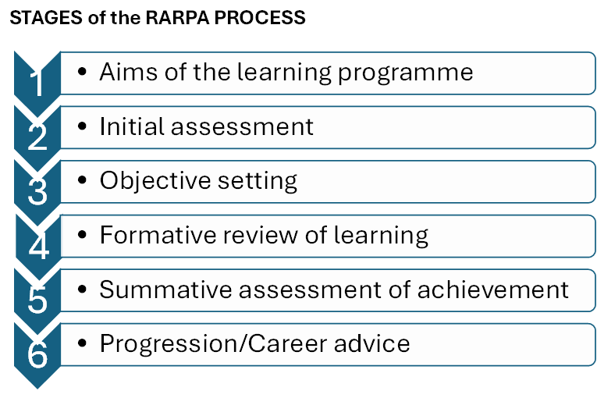
Further information can be found here-
ETF –
https://www.et-foundation.co.uk/professional-development/special-educational-needs-disabilities/teaching-and-learning/rarpa/
Learning and Work-
RARPA - Learning and Work Institute

Annex 3
Mayoral Combined Authority Approaches
Cambridgeshire & Peterborough
- CPCA is currently developing a Tailored Learning Policy for 2025-26.
- In 2024-25 CPCA is piloting a ‘Wider Outcomes Framework’ with delivery partners delivering community/tailored learning. This framework compliments RARPA and records and monitors the wider outcomes of participation in community/tailored learning.
- CPCA have adopted a hybrid approach for 2024-25 so that we have retained the core elements of community learning but have also introduced the 7 purposes of Tailored Learning for wider consideration.
- All delivery partners have been asked to complete a planning template for community/tailored learning.

https://cambridgeshirepeterborough-ca.gov.uk/news/a-new-era-for-adult-education-in-cambridgeshire-and-peterborough-set-for-launch/

East Midlands Combined County Authority (EMCCA)
- As a newly formed Combined Authority, EMCCA is currently consulting on their Adult Skills Fund strategy. The outcomes of Tailored Learning will be defined following the conclusion of the consultation.
- EMCCA will go live in 2025/26 and subject to the consultation outcome will adopt DfE’s approach to Tailored Learning as a transition year.
- EMCCA expects to develop their approach to Tailored learning to start in 2026/27.

www.eastmidlands-cca.gov.uk

Greater London Authority
- The Greater London Authority (GLA) has established a Tailored Learning fund that will incorporate all of the learning aims in the former Community Learning funding line and certain non-regulated, formula funded learning aims.
- A clearly defined group of specific ‘essential skills - core’ non-regulated learning aims will remain formula funded. Please see GLA Adult Skills Fund Funding and Performance Management Rules 2024/25 for further detail.

https://www.london.gov.uk/programmes-strategies/jobs-and-skills/training-providers-teaching-skills/adult-education-budget/information-aeb-providers

Liverpool City Region Combined Authority (LCRCA)
- LCRCA has retained notional indicative values for community learning, innovative delivery (which is locally known as test and learn) and DLS within Tailored Learning allocations, which colleges and providers are able to flexibly adjust between within their delivery plan.
- LCRCA requires a narrative Tailored Learning plan from Colleges and LA Learning Service with a Tailored Learning allocation, in much the same way providers have previously developed community learning plans.
- LCRCA encourages neighbouring colleges and local authority community learning providers to work collaboratively in planning their Tailored Learning curriculum through production and sharing of local plans.
- Costed plans for innovative delivery (Test and Learn innovative pilots) are detailed within College and Learning Provider delivery plans and their narrative Tailored Learning plan.
- Not all of non-regulated learning aims delivered to residents are sourced from the Tailored Learning funding line, with locally developed learning aims paid through funding model 38.
- Within LCRCA DLS funding rules an allowance is made available to Colleges and Learning Providers to support learner nutrition such as through breakfast clubs.

https://www.liverpoolcityregion-ca.gov.uk/policy-documents#AEB

Tees Valley Combined Authority (TVCA)
- Tees Valley redefined Community Learning in 2022/23 with what is now known in the Combined Authority area as Learning for Inclusion.
- This is ring-fenced budget for Local Authority learning organisations, based on the needs of the Local Authority area. The focus of Learning for Inclusion is:
  - Learning for personal development aimed at addressing the specific needs of adults within a Local Authority area such as isolation, social exclusion, mental health and well-being.
  - Learning that aims to improve and develop stronger community engagement.
  - Learning that supports local voluntary and other third sector organisations to develop their capacity to deliver learning opportunities for adults residing in the most disadvantaged neighbourhoods.

The Learning for Inclusion offer provides outreach support to engage adults experiencing multiple deprivation and programmes of learning designed to address these challenges.
Partnership working underpins the Learning for Inclusion objectives and is critical to developing and delivering an effective community learning offer in each locality. Providers must demonstrate how they will engage and work closely with a wide range of relevant partners, services, and stakeholders in a local area to help shape the community learning offer. These could include specialist partners, such as health, adult services, and voluntary and community sector (VCSE) organisations.

https://teesvalley-ca.gov.uk/work/skills-support/support-for-providers/

West Midlands Combined Authority (WMCA)
- WMCA retained the same funding values for Tailored Learning that were in place for Community Learning. This quantum of funding will continue to be protected.
- WMCA considers all 7 purposes equally important. Therefore, there is no “primary purpose” as stated in section 2 of this document.
- The notion of Tailored Learning and practice of using formula funded learning aims in tailored programmes exists at the WMCA since 2020. For this reason, WMCA will not be moving any non-regulated formula funded learning aims into Tailored Learning.
- The underlying principle of Tailored Learning at WMCA is to fulfil the goals of Pillar 1 of our Employment and Skills Strategy “Building Stronger and Inclusive Communities”
- In fulfilling these goals, it is expected that learning organisations will design Tailored Learning provision that will develop learners’ Cultural Capital and Social Capital.
- Learning organisations offering Tailored Learning will collaborate with Voluntary Community Sector Organisations specialised in “first engagement and stabilisation” of the hardest to reach citizens in our communities.
- Tailored Learning will be a holistic learning offer in the community that may include (mental) health support and other programmes to overcome inequalities, including health inequalities. Examples of supplementary programmes that will be part of Tailored Learning are Thrive into Work and Universal support. These will be provided in response to individual needs and learner request.

https://www.wmca.org.uk/what-we-do/employment-and-skills/adult-education-budget/skills-programme-documents/

West Yorkshire Combined Authority (WYCA)
- WYCA are adopting the term ‘Tailored Learning’ to refer to what was AEB Community Learning.
- Our definition of ‘Tailored Learning’ does not include formula-funded AEB non-regulated learning (previously delivered through adult skills) and any new employer-facing innovative provision that is not qualification based. Therefore, the rules below refer to Non-formula Tailored Learning Funding.
- We do not allow Tailored Learning funding to be used for learning primarily or solely for leisure purposes. We define learning for leisure purposes as learning where the primary or sole intent of the learning is for leisure. Within the Eligibility Principles we have an additional point (not in ESFA rules) ‘it must not be used primarily or solely for ‘leisure’ purposes.’
- We have the additional point in our Funding Rules ‘ESOL delivered through Tailored Learning must not duplicate funded qualifications. Provision should have a focus on wider integration, practical application, practice of language skills and confidence building.’
- For 2023/24 (and continuing for 2024/25) WYCA added into the rules that Outreach can be funded under Tailored Learning. Tailored Learning funding can be utilised to engage and deliver in the community e.g., room hire and/or key worker and/or commissioning models.
- Tailored Learning for Health and Wellbeing can be delivered where individuals demonstrate their suitability based on their personal circumstances and needs related to health and wellbeing. A well-defined personal progression plan must be included as part of the Individual Learning Plan (ILP) requirement.

West Yorkshire AEB Funding Rules 2022-23 (v4) (westyorks-ca.gov.uk)

Other MCA areas not included will be confirmed in coming weeks.

Annex 4

Working Group
This guidance has been created by a working group consisting of adult educators and DfE/MCA/GLA/sector body representatives. Many thanks to all of those involved below.
Name | Organisation
Marguerite Hogg | AoC
Jayne Stead | Calderdale Metropolitan Borough Council
Jaki Bradley | Cambridgeshire and Peterborough Combined Authority
Barbara Hamilton | City of London
Louise Lakin | Coventry City Council
Rosemary Maclennan-Crump | Derbyshire County Council
Charlotte Piper | DfE
Helen Guezelkuecuek | DfE
Lucy Rayfield | DfE
Debbie Ormshaw | Doncaster Metropolitan Borough Council
Melanie Crosby | Gateshead Council
Christopher Wright | Greater London Authority
Chantel Le Carpentier | Greater London Authority
Gemma Jeffrey | Hertfordshire County Council
Charlie McKenna | HOLEX
Sue Pember | HOLEX
Jude Farrell | Kent County Council
Jeanette Palmer | Kirklees Council
Gillian Forrester | Newcastle City Council
Katie Tarrant | Northern College
Miguel Silva | West Midlands Combined Authority
Andrew Bishop | West Sussex County Council
Dipa Ganguli | WM College
Prue Gibson | Workers Educational Association
Gerald Jones | London Borough of Haringey

Annex 5
Consultation Respondents
Angela | Rooney | ACL Delivery Manager | Warwickshire Adult & Community Learning Service
David | Coleman | Assistant Principal Student Service | Redbridge Institute Adult Education
Helen | Osborne | Self-employed freelancer | Helen Osborne
Jacqueline | Wilson | Principal of Adult and Community Learning | Buckinghamshire Council
Fay | Stone | Vice Principal | Thurrock Adult Community College
Lisa | Marklew | Director of Learning | Working Men's College
Paul | Cliff | Shared Head of Adult Learning and Skills (York and North Yorkshire) | North Yorkshire and City of York Councils
Marc | Jordan | Head of Brent Start | Brent Adult Education (Brent Start)
Simon | Parkinson | CEO | WEA
Lindsey | Moulds | Data and Performance Lead | Community Learning in Partnership
Ziya | Moustafa | Director of Learning, Learning and Life Skills | WM College
Chris | Dempsey | Business and Information Manager | Adult Learning
Caroline | Elgood | Quality Manager | Suffolk County Council
Angela | Padfield | Head of York Learning | York Learning
Sam | Burgess | Principal | Kingston Adult Education part of Royal Borough of Kingston
Dawn | Sweeney | Adult Skills Development Officer | St Helens Council
Rosemary | MacLennan-Crump | Learning and Skills Manager - Tailored Learning | Derbyshire County Council - Adult Community Education Service
Ljiljana | Colak | Senior Manager - Partnerships and Employability | Hammersmith and Fulham Adult learning and Skills Service
Kevin | Thorpe | Head of Adult Skills and Community Learning | Royal Borough of Greenwich
Andrew | Bishop | Adult Learning Manager | West Sussex County Council
Chris | Butcher | Senior Policy Manager | WEA
Arinola | Edeh | Principal | Westminster Adult Education Service
Robin | Hindley | Vice Principal | Capital City College Group
Howard | Croft | Senior Curriculum & Operations Manager | Coventry City Council
Debbie | Ormshaw | Quality Manager | AFCL - City of Doncaster Council
Rob | Brindley | Service Manager | Isle of Wight Council
Helen | Doel | Performance and Quality Manager | Northamptonshire Adult Learning
liz | Barrett | Principal | Academy Transformation Trust Further Education College (ATTFE College)
Sarah | Rice | Curriculum & Quality Manager | Skills & Learning Adult Community Education (BCP Council)
Ceri | Fishlock | MIS Lead | Essex County Council (ACL Essex)
Richard | Smith | Service Manager - FACES | Lifelong Learning and Skills, Sheffield CC
Barbara | Hamilton | Head of Adult Skills Education and Apprenticeship | City Of London Corporation
Harriet | Duncan | adult learning manager | Royal Borough of Kensington and Chelsea
Clare | Roberts | Quality and Performance Manager | Staffordshire CC
Shani | Bragg | Community Learning Manager | Buckinghamshire Adult Learning (Family Learning)
Rowena | Prentice | Family and Community Learning Manager | Wiltshire Council
Tracey | Wood | Assistant Principal | The Trafford and Stockport College Group
Jenny | Riordan | Skills & Quality Manager | Lincolnshire County Council
Tracy | Kelly | Quality Lead - Skills and Apprenticehsips | Adult Education In Gloucestershire
Darren | Kirwin | Head of Curriculum and Quality | Bromley Adult Education
Peter | Jeffryes | Curriculum Manager | Community Learning and Skills - Kent Adult Education
Helen | Hart | Head of Funding & Performance | Bromley Adult Education College
Ann | Bryant | Data and Performance Manager | Realise Futures
Tracy | Hammond | Quality and Performance Officer | Bracknell Forest Council
Jayne | Stead | Quality Manager | Calderdale Adult Learning
Jeanette | Palmer | Principal for Adult Programmes | Kirklees LA
Lisa | Welch | Deputy Principal | Reading Borough Council - New Directions College
Lorraine | Davison | Adult Learning Manager | Southampton City Council

