

Digital Policy Guidance Materials


Annex 4

Sutton College of Adult Education
Digital Strategy 2020-2023

The Digital Service at the College will provide a coordinated, user-centric approach to the development and delivery of high quality, cost effective ICT systems and services and end user support functions. We will do this by working across the college with colleagues, learners, local authority and external partners to support and enable meaningful and sustained improvements to all aspects of our operation.
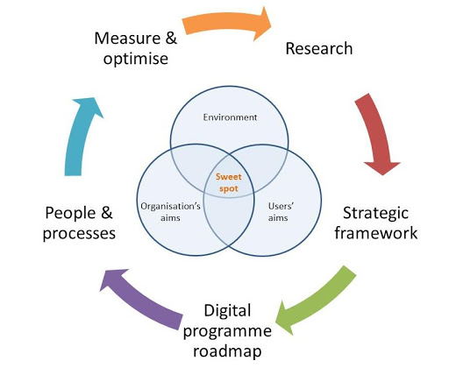
The strategic aims underpinning the College Digital Strategy are:

- To Deliver an Excellent Experience – our end users should expect, and receive, an excellent digital experience in every interaction they have with us.
- To Be Digital by Design – our procedures and processes will be designed to be digital, with a sharp focus on meeting the needs of our end users.
- To Offer Flexibility and Freedom of Choice – our end users will be empowered to make choices about how and when they interact with us.
- To Prioritise Cyber Security and Resilience – we will embed cyber security and resilience at the core of our approach to developing and delivering systems and services to our end users.
To Use Systems and Process Improvement to Drive Efficiency – we recognise the role that systems and processes can have in delivering operating efficiencies and will use them to improve our organisational effectiveness.

